The 8th World Indigenous Women & Wellness Conference

CALL FOR PRESENTATIONS

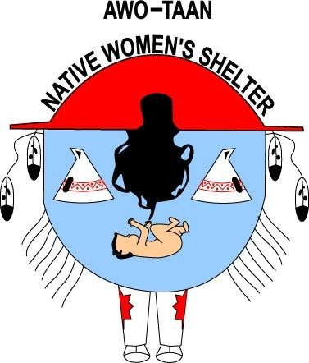

Hosted by Awo Taan Healing Lodge

The 8th World Indigenous Women & Wellness Conference will be an excellent opportunity for participants from across the globe to share information, innovative initiatives, models, research and best practices on Family Violence and Indigenous Peoples. The conference will also provide participants with the opportunity to network.

The Planning Committee is currently searching for presenters who are willing to share their models, innovative programs or initiatives and research with Conference participants. This document outlines how presenters can become involved in The 8th World Indigenous Women & Wellness Conference

Conference Theme

Building on Traditional Knowledge & Wisdom

There will be 7 conference principle themes that will run throughout the Conference.
Possible topics include, but are not limited to:

Theme 1 Healthy and Positive Futures for our Communities

Theme 2 Children & Youth

Theme 3 Embracing our Elders/Tradition Knowledge & Wisdom

Theme 4 Reclaiming and Valuing Traditional Languages

Theme 5 Prevention & Intervention Issues of Violence and Relationships

Theme 6 Engaging Men in Ending Violence

Theme 7 Effective Strategies

Submissions on these and related topics are welcome from fields including, but not limited to, indigenous history, language, cultural studies, art history, health, children and youth.

Please send abstracts of 300 words of less, and a one page CV to
maryanns@awotaan.org or awotaan@awotaan.org

Papers should be no longer than 30 minutes. Submissions can be made in English only.
The Deadline for presentation submissions is February 21st, 2008.
To be held at The Westin Hotel, Calgary, Alberta CANADA
For more information please contact:
Maryanns@awotaan.org or awotaan@awotaan.org
(403) - 561 – 1610 or Fax: (403) - 531 - 1977

Call for Papers:
We have invited paper presentations from people who are actively engaged in conducting participatory research alongside or within Aboriginal and/or other Indigenous communities. We are particularly interested in research that has been instigated in the first instance by Indigenous communities.

Conference Themes:

Conference papers will address at least one of the following conference sub themes.

Healthy and Positive Futures for our Communities

Papers should highlight research that:

- Contributes to promoting wellness in home environments for Aboriginal and/or Indigenous communities
- Strengthens the generations.

Papers must address the aims of the conference and may include discussion about:
- Aboriginal and Indigenous priorities and dilemmas
- Academic priorities and dilemmas
- The research process.
Effective Strategies:

Papers should highlight research that:

- Is geared towards improving the lives of Aboriginal and/or indigenous peoples regionally and/or globally.
Papers must address the aims of the conference and may include discussion about:
- Aboriginal and indigenous priorities and dilemmas
- Academic priorities and dilemmas
- The research process.
Frontiers of Knowledge:

Papers must address the aims of the conference and may include discussion about:

- Traditional knowledge and widsom
- Transforming academic examples.
We are looking for contributions on, but not limited to, the following topics:
- Traditional knowledge of Indigenous communities
- Culture and the role of community relationships
- Language, environment and indigenous traditions
- Health and well-being research initiatives in Aboriginal and indigenous communities
- Violence and indigenous peoples
- Cultural identity, resistance and research.

Conference Objectives and Outcomes:
Indigenous populations around the world face rapid social, political, environmental and economic change in the face of challenges of cultural identities and tradition. Academic scholarship must keep pace if it is to remain relevant to indigenous communities and societies.
Research methods and academic practices have begun to evolve within indigenous communities, which in turn present new questions and challenges for academic scholarship and practice.
Aims of the Conference:
This conference aims to bring together people from a range of disciplinary fields and nations who are engaged in developing responses to global challenges of Aboriginal and/or other indigenous peoples. The purpose is to identify common themes and key issues, and explore ideas for the future.
The conference is intended to help professionals, practitioners and researchers to locate themselves within a range of intellectual forums that are closely engaged with emerging issues. The conference will allow a sharing of knowledge, expertise and insight between both established and newly emerging networks of aboriginal and indigenous professionals and community researchers.
Guidelines:
- Maximum length of 300 word summary
- Submissions in English only
- All Presenters must provide brief (one page) biographies.

Presentation Process:
Only submissions completed by the deadline will be considered. The Conference Presentation Selection Committee reserves the right to combine presentations into Oral Presentations of similar topics.

Special Considerations:
Special Consideration will be given to the following:
- Indigenous youth presenters and organizations or presenters working directly with Indigenous youths.
- Indigenous Elder presenters and organizations that work with Indigenous Elders and
- Indigenous community member presenters.

“Presenters may show case Indigenous family, community, regional and national or
international best practices and innovative models and strategies for programs and initiatives
focused on Indigenous health relationships and communities.”

SUBMISSION DEADLINE

The Submission Deadline is Thursday February 21st, 2008

