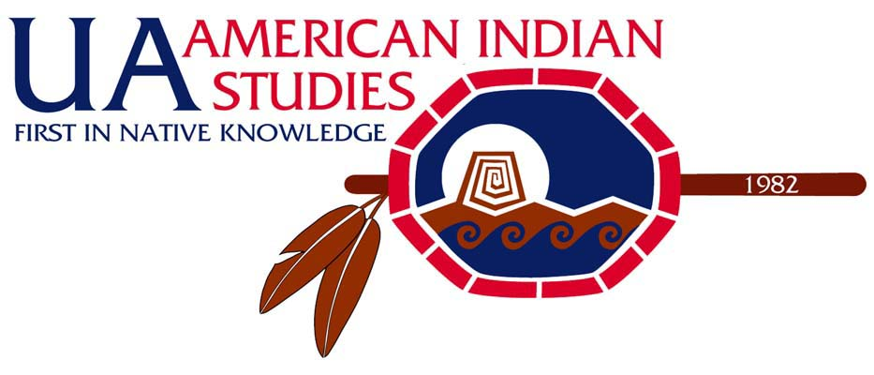 | Vine Deloria, Jr. Distinguished  Indigenous Scholars Series  Fall 2008 Presents
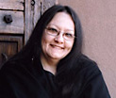 | Suzan Shown Harjo September 8-12, 2008  (Cheyenne & Hodulgee Muscogee/Creek) President & Executive Director, The Morning Star Institute  Public Lecture “Nobody Gives Us Sovereignty: Busting Stereotypes & Walking the Talk”  Tuesday, Sep. 9, 7 pm, Education 211/Kiva Auditorium  1430 East 2nd Street. South of Cherry, just east of Second Street garage
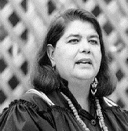 | Wilma Mankiller September 29-October 3, 2008  (Cherokee) former Principal Chief of the Cherokee Nation  Public Lecture “What it Means to be an Indigenous Person in the 21st Century: A Cherokee Woman’s Perspective”  Tuesday, Sep. 30, 7 pm, Gallagher Theater, Student Union
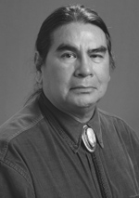 | Dr. Richard L. Allen October 20-24, 2008  (Cherokee) Policy Analyst, Cherokee Nation  Public Lecture “The Revitalization of the Cherokee Nation: A Contemporary Perspective”  Tuesday, Oct. 21, 7 pm, Education 211/Kiva Auditorium  1430 East 2nd Street. South of Cherry, just east of Second Street garage
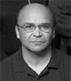 | Dr. David E. Wilkins November 10-14, 2008  (Lumbee) Professor, American Indian Studies & Law, University of Minnesota  Public Lecture “Putting the Noose on Tribal Citizenship: Modern Banishment & Disenrollment”  Thursday, Nov. 13, 7 pm, Education 211/Kiva Auditorium  1430 East 2nd Street. South of Cherry, just east of Second Street garage

Co-sponsored by Office of Student Affairs, Center for Student Involvement and Leadership, The Native Nations Institute, Department of Geography and Regional Development
For more information: http://aisp.web.arizona.edu/ AIS office 621-7108; Prof. Tom Holm 621-5083; or Tarissa Spoonhunter 621-8446

