[Authors, Verdana, 11 pt] T. Aculeatus^{*1}, F. Ruysch², J.C. Kaïserling³, G.-L. L. de Buffon¹ | 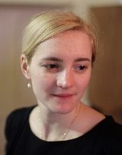  [Picture of the contacting author, 4.5 x 3.5 cm]
[Title, Verdana,16pt ] Preservation of wet collections

[Subtitle, if relevant, Verdana, 14pt]

[250 word max, Verdana, 11pt] Lorem ipsum dolor sit amet, consectetur adipiscing elit. Etiam id ligula vitae nulla mattis efficitur. Fusce lobortis ante nec consectetur luctus. Mauris elit nulla, malesuada vel condimentum malesuada, volutpat sed orci. Mauris pharetra finibus erat sit amet finibus. Vivamus rutrum semper diam eleifend aliquet. Integer eleifend lectus in ornare consequat. Cras facilisis, nulla vel finibus sodales, sem dolor mattis enim, quis scelerisque risus purus ac lectus (Fig.1).
Nulla facilisi. Donec blandit nec eros et fringilla. Morbi sem odio, accumsan non purus eu, consectetur dapibus augue. Vivamus est orci, imperdiet euismod diam et, imperdiet hendrerit arcu. Nulla orci purus, ultricies sed congue sit amet, sollicitudin vitae quam. Cras eget augue vehicula mi consectetur porta. Morbi interdum neque ut urna ultrices, varius aliquam lectus fermentum. Proin sit amet congue mauris, eget interdum odio. Donec ullamcorper ut justo a tempus. Etiam eu aliquam nunc (Fig.2.).
Nullam semper ornare ex sit amet bibendum. Pellentesque sit amet libero imperdiet, finibus leo mollis, dignissim ipsum. Maecenas vitae eros ligula. Vestibulum et libero vel elit fringilla dictum quis vehicula leo. Phasellus ornare eget dolor sed viverra.
[Contacting author’s contact details + co-author affiliation(s), Verdana, 8pt]
^{*1} Contacting author : Muséum national d’Histoire naturelle, Paris, FR.
Tel :+33.1.40.79.53.0, Email : tjirili @mnhn.fr
² Surgeons Guild of Amsterdam, Amsterdam, NDL.
³ University of Königsberg, Königsberg, DEU.

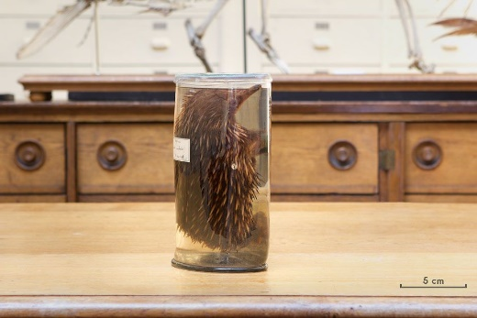 |  | 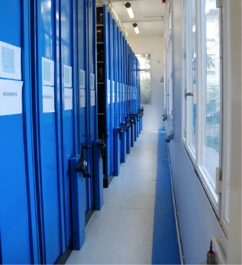
Fig. 1 : Short-beaked echidna  (© MNHN – E. Bab) |  | Fig. 2: Home  (© MNHN – M. Herbin)
[Please provide two figures (8.5 x 6 cm) with their legend (Verdana, 9 pt). Do not forget to mention them in the text and to indicate copyrights]

