NOMINee

Name:
Institution:
Institution Address:
City: |  |  |  | Postal Code:
Telephone: |  | Ext.: |  | Email:
Home Address:
City: |  |  |  | Postal Code:
Telephone: |  | Ext.: |  | Email:

NOMINATORS
Each nomination must be supported and signed by at least three (3) persons, two (2) of which may be affiliated with the institution of the nominee.

Name:
City: |  |  |  | Postal Code:
Telephone: |  | Ext.: |  | Email:
Signature:
Name:
City: |  |  |  | Postal Code:
Telephone: |  | Ext.: |  | Email:
Signature:
Name:
City: |  |  |  | Postal Code:
Telephone: |  | Ext.: |  | Email:
Signature:

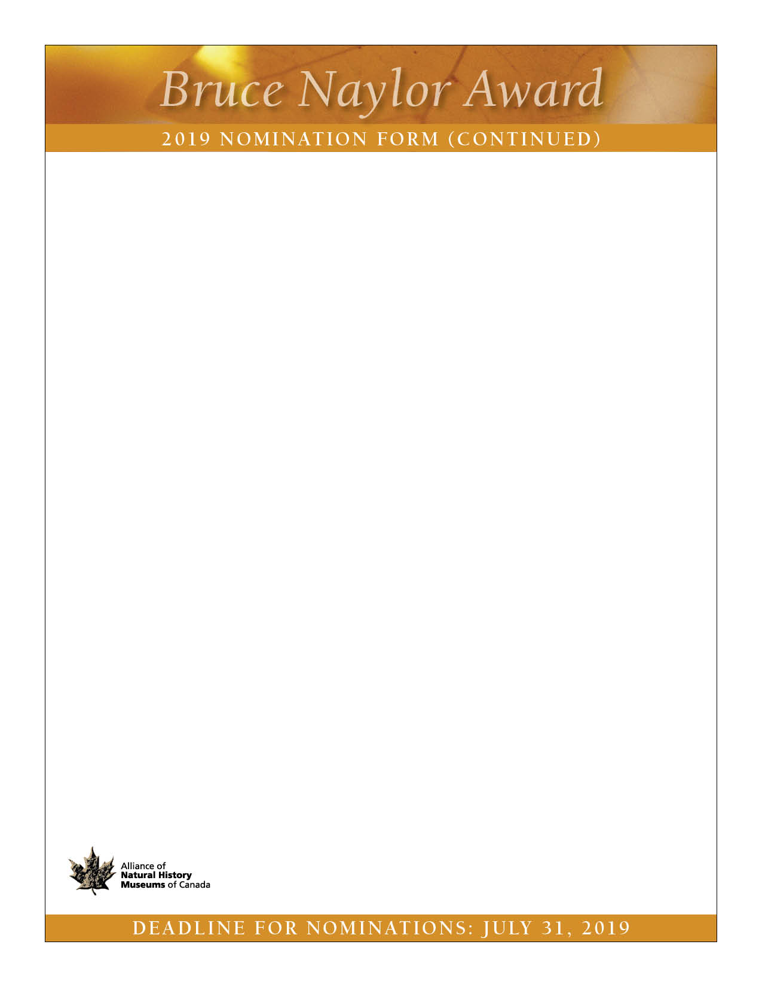
CITATION
Required, 350-500 words.

CONTRIBUTIONS AND Explanation of what makes the Nominee’s achievement exceptional
Please attach explanation of achievement (maximum two (2) typed pages).

Letters of Support

Current Resume of Nominee
Required, maximum six (6) pages.

Additional Support Material Provided (optional, please mark with an “x” all that apply):
Sample of publications or articles (up to five, submitted as PDFs)
Photographs (up to three, accompanied by a caption, submitted as digital files)
Details of exhibitions curated or developed (up to three)
Other supporting material, such as website links, brochures, media files or clippings (up to three)
Other (please specify):

The nomination form plus copies of all supporting material should be submitted by e-mail by July 31, 2019 to:
The Bruce Naylor Award
The Alliance of Natural History Museums of Canada
C/O Elizabeth McCrea
Tel.: (613) 410-1199
Email: mccrealiz@gmail.com

The Bruce Naylor Award will be presented at the annual general meeting of the Alliance of Natural History Museums of Canada
in the Fall of 2019.

