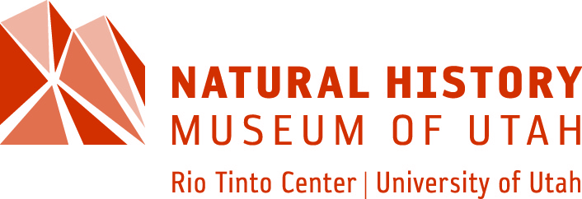

**Executive Director**

**Salt Lake City, UT**

As the designated state museum of natural history, the Natural History Museum of Utah serves rural and urban communities across the state through its exhibits, educational programs, citizen science, and broad outreach activities. By providing access to these collections and through its insights into Utah’s rich natural history, the Museum serves as a threshold to all that Utah’s natural places have to offer, inspires curiosity, and communicates science to wide audiences.

The Museum seeks an innovative and visionary leader who demonstrates a passion for engaging others in a lifelong learning agenda while delivering a high-quality experience that is financially sustainable through solid program, engagement, fundraising and business practices. A deep understanding, appreciation for, and connection to the natural world through collections-based science is required.

A high level of experience in building and sustaining community, national and international partnerships with other educational and cultural stakeholders, public and private, is necessary. The Museum seeks a dynamic, energetic communicator who can influence others to action, be they staff, faculty, board members, donors, elected officials, corporate executives, members, volunteers, and other supporters.

The ideal candidate will show evidence of successful fundraising leadership or will address how he/she/they have the aptitude to be successful with acquiring major gifts and grants from foundations, corporations, individuals and the public sector at the local, state and national level. A background of launching innovative, groundbreaking programs resulting in long-term funding and stable revenue streams, world-class research, and dynamic public engagement is highly valued.

A Master’s degree is required. Formal education in science is preferred, but not required. Demonstrable leadership experience in public or private institutions concerned with informal education, natural history/science or related professions is highly valued.

Applications and nominations are being received by Kittleman & Associates, LLC. To apply, submit a current resume, letter of interest, and a diversity statement (a document that addresses your commitment to diversity, equity, and inclusion through work, professional activity or service) to Kittleman at <https://ww2.kittlemansearch.com/Jobs>

For more information about the Natural History Museum of Utah, visit [https://nhmu.utah.edu/](https://nhmu.utah.edu/%20kittlemansearch.com/Jobs)

*Diversity & Inclusion Statement*

*At the Natural History Museum of Utah, we recognize that our strength and sustainability as an organization stems from diversity and inclusion. For this reason, we are committed to fostering equity, recruiting and retaining a diverse workforce that reflects the communities we serve, and empowering staff members in developing an accessible and inclusive work environment.*