GCNHM CATALOG #: GCM 3422
SPECIMEN DESCRIPTION: RANGIFER TARANDUS CARIBOU SHOULDER MOUNT

ACC# 4.2010.1 ACC DATE: 9 JUNE 2010

DONATOR: RIDGEROAD ELEMENTARY VALUE: NA
COUNTRY OF ORIGIN: UNITED STATES
ORIGINAL ID #: USFW2005701154P009 ORIGINAL TRANSFER DATE: 31 MAY 2006

NOTES: WILL NEED USFW REASSIGNMENT PAPERWORK
__________________________

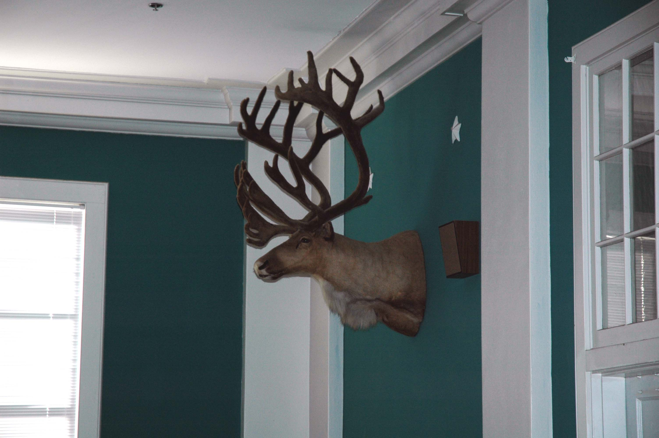
GCM3422 BEFORE ACQUISITION

GCNHM CATALOG #: GCM 3423
SPECIMEN DESCRIPTION: ALCES ALCES MOOSE SHOULDER MOUNT

ACC# 4.2010.1 ACC DATE: 9 JUNE 2010

DONATOR: RIDGEROAD ELEMENTARY VALUE: NA
COUNTRY OF ORIGIN: UNITED STATES
ORIGINAL ID #: USFW2005701154P011 ORIGINAL TRANSFER DATE: 31 MAY 2006

NOTES: WILL NEED USFW REASSIGNMENT PAPERWORK
__________________________

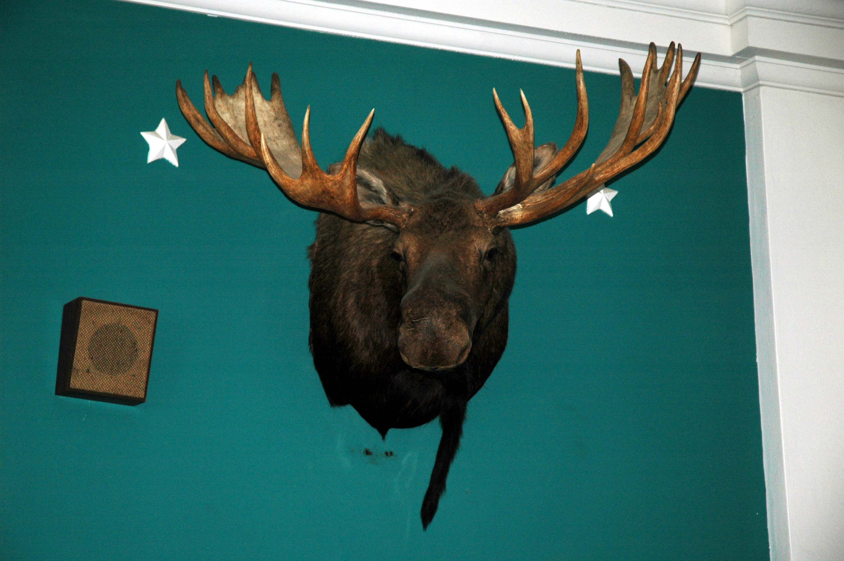
GCM3423 BEFORE ACQUISITION

GCNHM CATALOG #: GCM 2559
SPECIMEN DESCRIPTION: BUBALUS BUBALUS WATER BUFFALO ‘LEGACY PREP’ FULL MOUNT

ACC# 4.2010.1 ACC DATE: 9 JUNE 2010

DONATOR: RIDGEROAD ELEMENTARY VALUE: $3500
COUNTRY OF ORIGIN: AUSTRALIA INST. DISPOSAL #: SMITHSONIAN MUSEUM #2034799
ORIGINAL ID #: NMNH VZ KEB232 ORIGINAL TRANSFER DATE: 23 SEP 2004
_______________________________

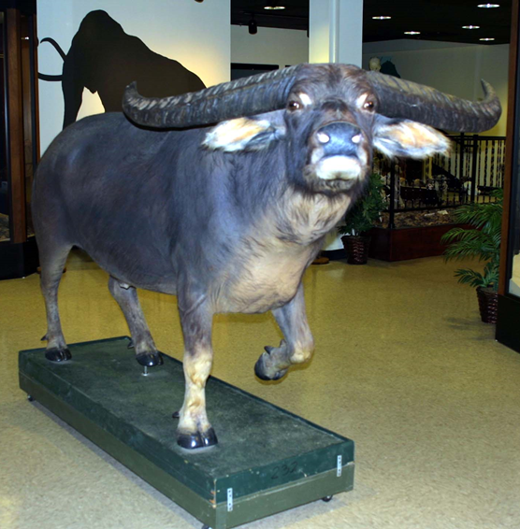
GCM2559 AFTER ACQUISITION

GCNHM CATALOG #: GCM 2561
SPECIMEN DESCRIPTION: ORYX LEUCORYX ARABIAN ORYX ‘LEGACY PREP’ FULL MOUNT

ACC# 4.2010.1 ACC DATE: 9 JUNE 2010

DONATOR: RIDGEROAD ELEMENTARY VALUE: $4000
COUNTRY OF ORIGIN: UNITED STATES INST. DISPOSAL #: SMITHSONIAN MUSEUM #2034799
ORIGINAL ID #: NMNH VZ KEB281 ORIGINAL TRANSFER DATE: 23 SEP 2004

NOTES: IUCN REDLIST STATUS: VULNERABLE 2016 ____________________________________________________

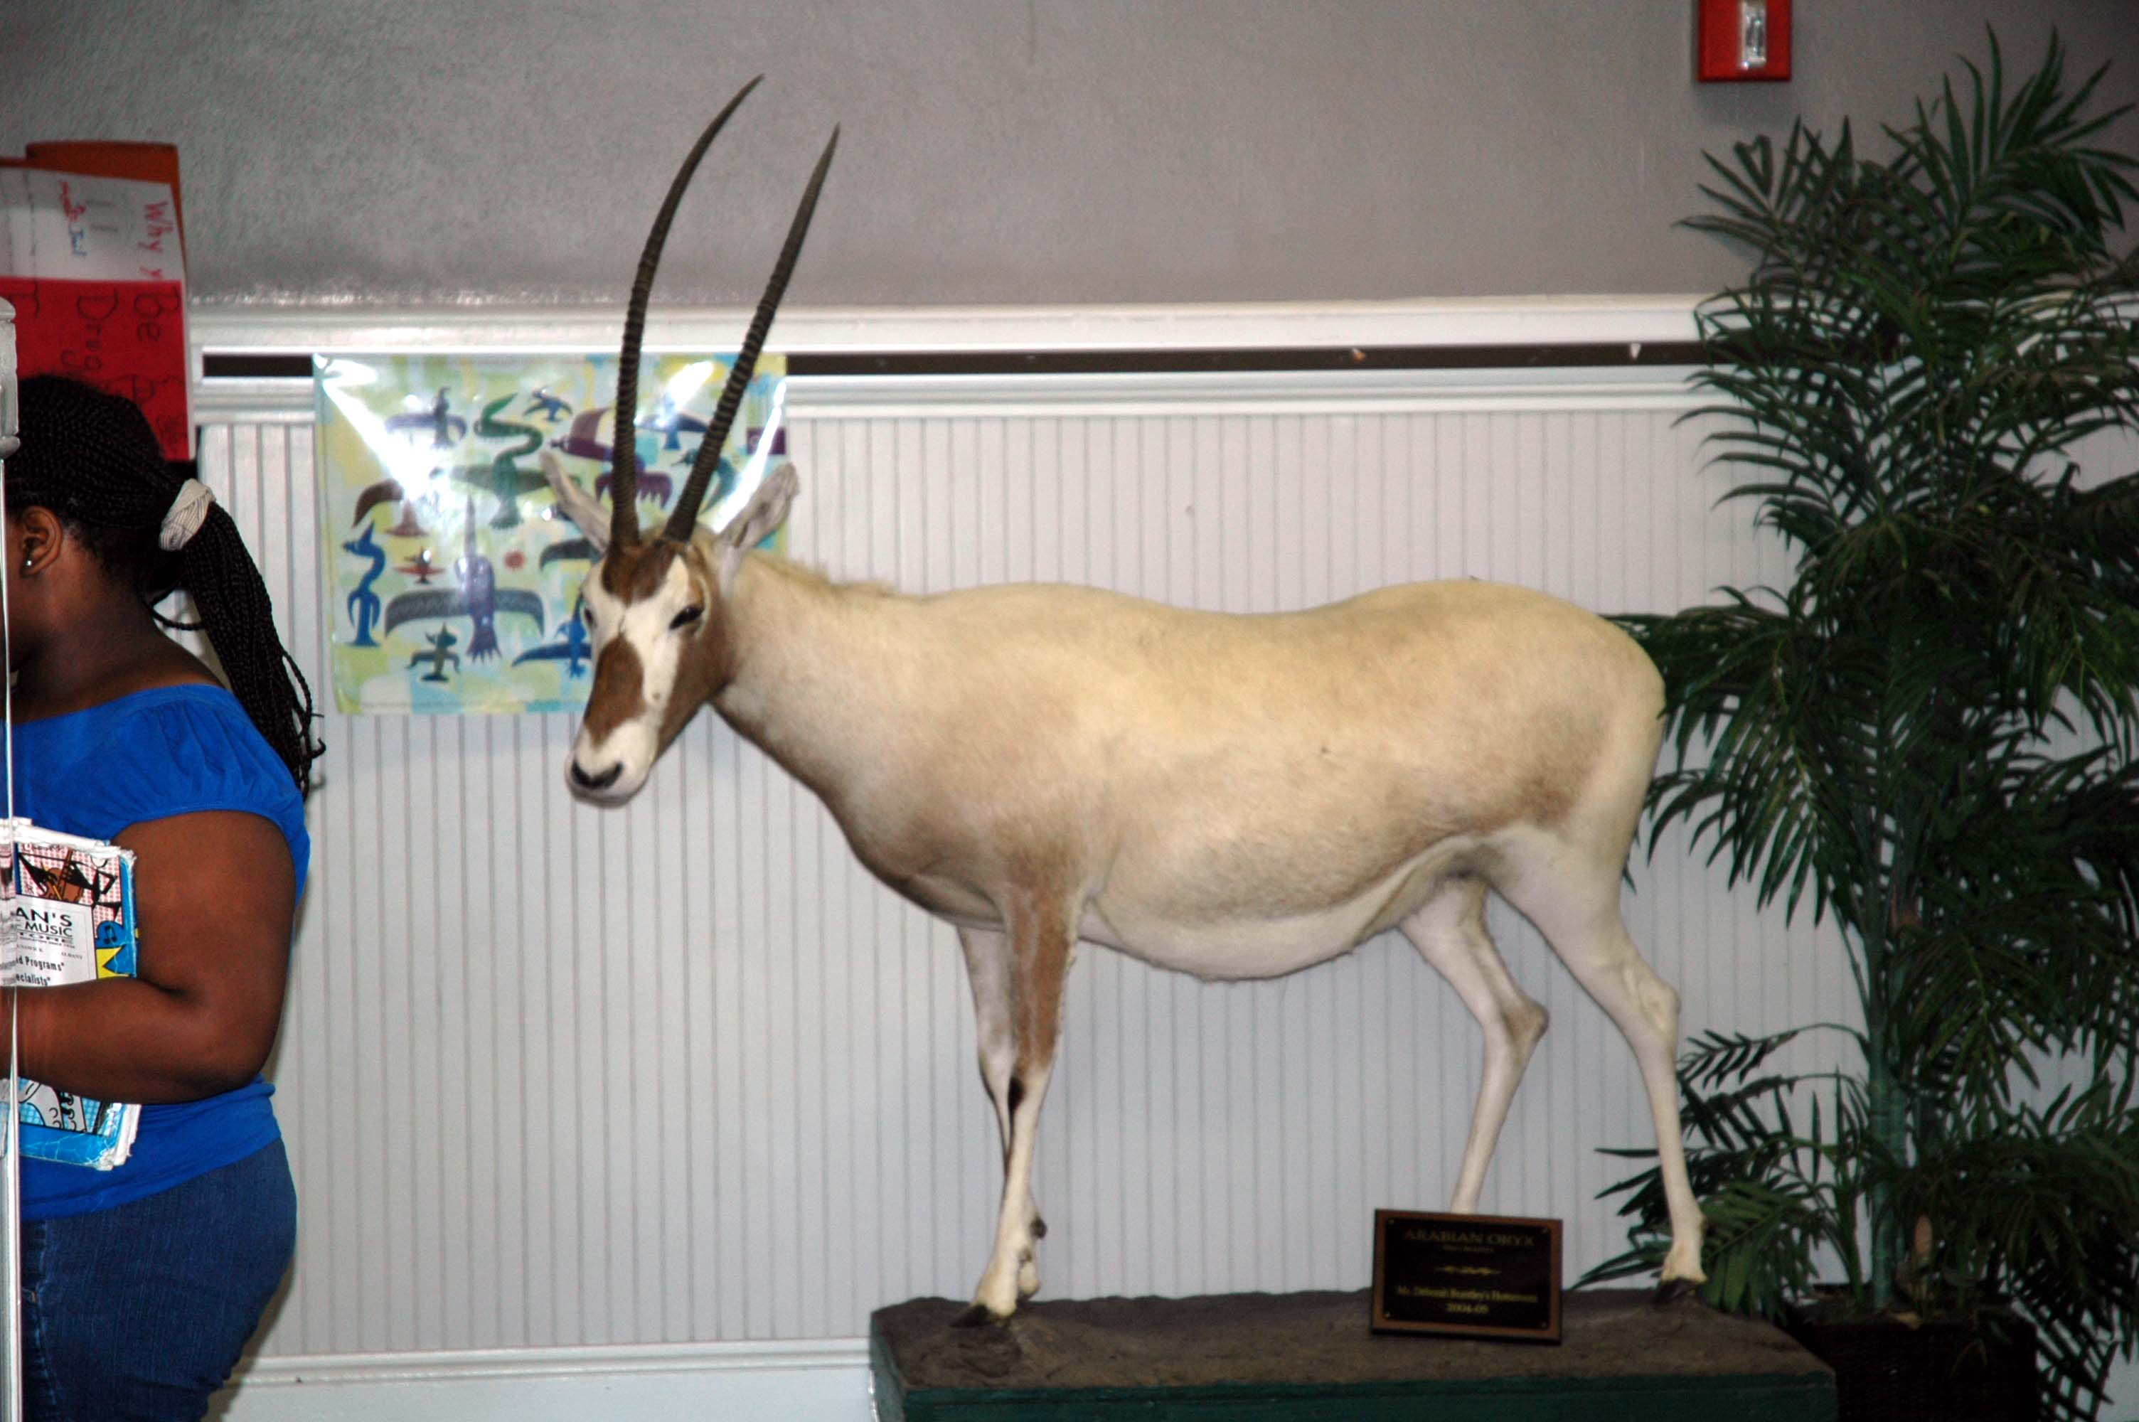
GCM2561 BEFORE ACQUISITION

GCNHM CATALOG #: GCM 2562
SPECIMEN DESCRIPTION: AEPYCEROS MELAMPUS IMPALA ‘LEGACY PREP’ FULL MOUNT

ACC# 4.2010.1 ACC DATE: 9 JUNE 2010

DONATOR: RIDGEROAD ELEMENTARY VALUE: $4000
COUNTRY OF ORIGIN: UNITED STATES INST. DISPOSAL #: SMITHSONIAN MUSEUM #2034799
ORIGINAL ID #: NMNH VZ KEB301 ORIGINAL TRANSFER DATE: 23 SEP 2004
___________________________

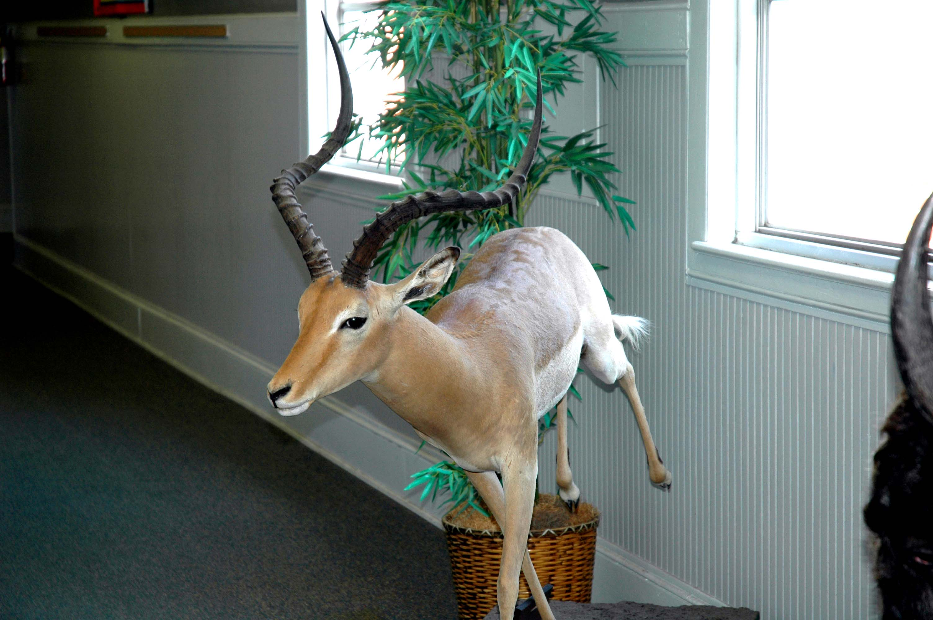
GCM2562 BEFORE ACQUISITION

.

GCNHM CATALOG #: GCM 2563
SPECIMEN DESCRIPTION: BOS GRUNNIENS YAK ‘LEGACY PREP’ FULL MOUNT

ACC# 4.2010.1 ACC DATE: 9 JUNE 2010

DONATOR: RIDGEROAD ELEMENTARY VALUE: $5000
COUNTRY OF ORIGIN: UNITED STATES INST. DISPOSAL #: SMITHSONIAN MUSEUM #2034799
ORIGINAL ID #: NMNH VZ KEB333 ORIGINAL TRANSFER DATE: 23 SEP 2004

NOTES: IUCN REDLIST STATUS: VULNERABLE 2016 ____________________________________________________

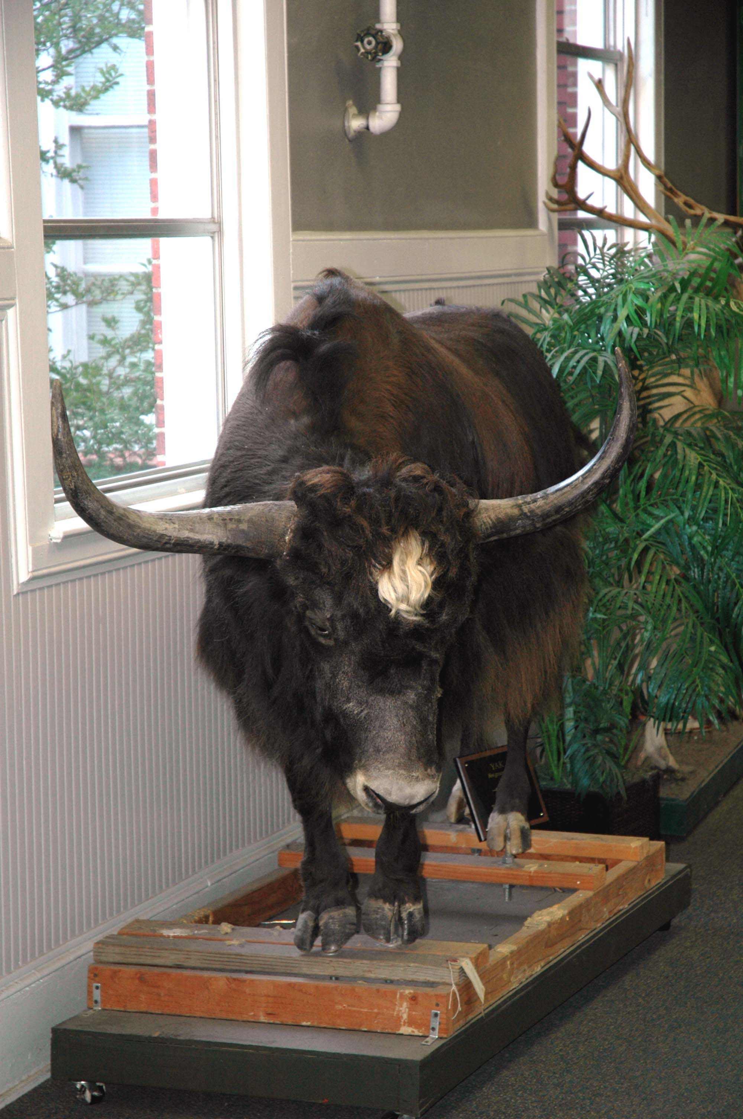
GCM2563 BEFORE ACQUISITION

