**Question:**

How do I meet the RFQ requirements for proof of insurance?

**Answer:**

You do not need to provide proof of insurance with your quote. Additionally, the Smithsonian

does have a Commercial General Liability Insurance policy that individuals can elect to

purchase. The fee amount is based on the total price of the contract, but tends to be less

expensive than if you purchase an external policy. The amounts are listed below:

$

40,001

Contract Amount $0-

$1,001-

$5,001-

$12,500

$12,501- $20,001- -

$50,001-

$

1,000 $5,000

$20,000 $40,000 $50,000 $75,000

Insurance Payment

$

25.00 $35.00

$40.00

$55.00 $95.00

$125.00 $170.00

If you’d like, you may include a note on your quote that you intend to enroll in SI’s CGL policy.

**Question:**

Would we report mainly to the NHB [Natural History Building in Washington DC] or at MSC

[

Museum Support Center in Suitland MD]? Or is it more of an even split between locations?

**Answer:**

Most of the project will be at NHB, but there could be blocks of days or weeks at the MSC.

**Question:**

I wanted to clarify if contractors on this project are expected to meet the 2080 hours each

period or is it more that the hours are available to us if we were to choose to not take time off?

**Answer:**

My recommendation is to put your availability (such as hours per week and total number of

hours) in the quote. The RFQ includes a maximum number of hours but not a minimum.

**Question:**

Are quotes for fewer than 2080 hours being considered?

**Answer:**

My recommendation is to put your availability (such as hours per week) in the quote. The RFQ

includes a maximum number of hours but not a minimum. Remember that you will not get sick or vacation time so you may want to reduce the total number of hours you bid to accommodate time off.

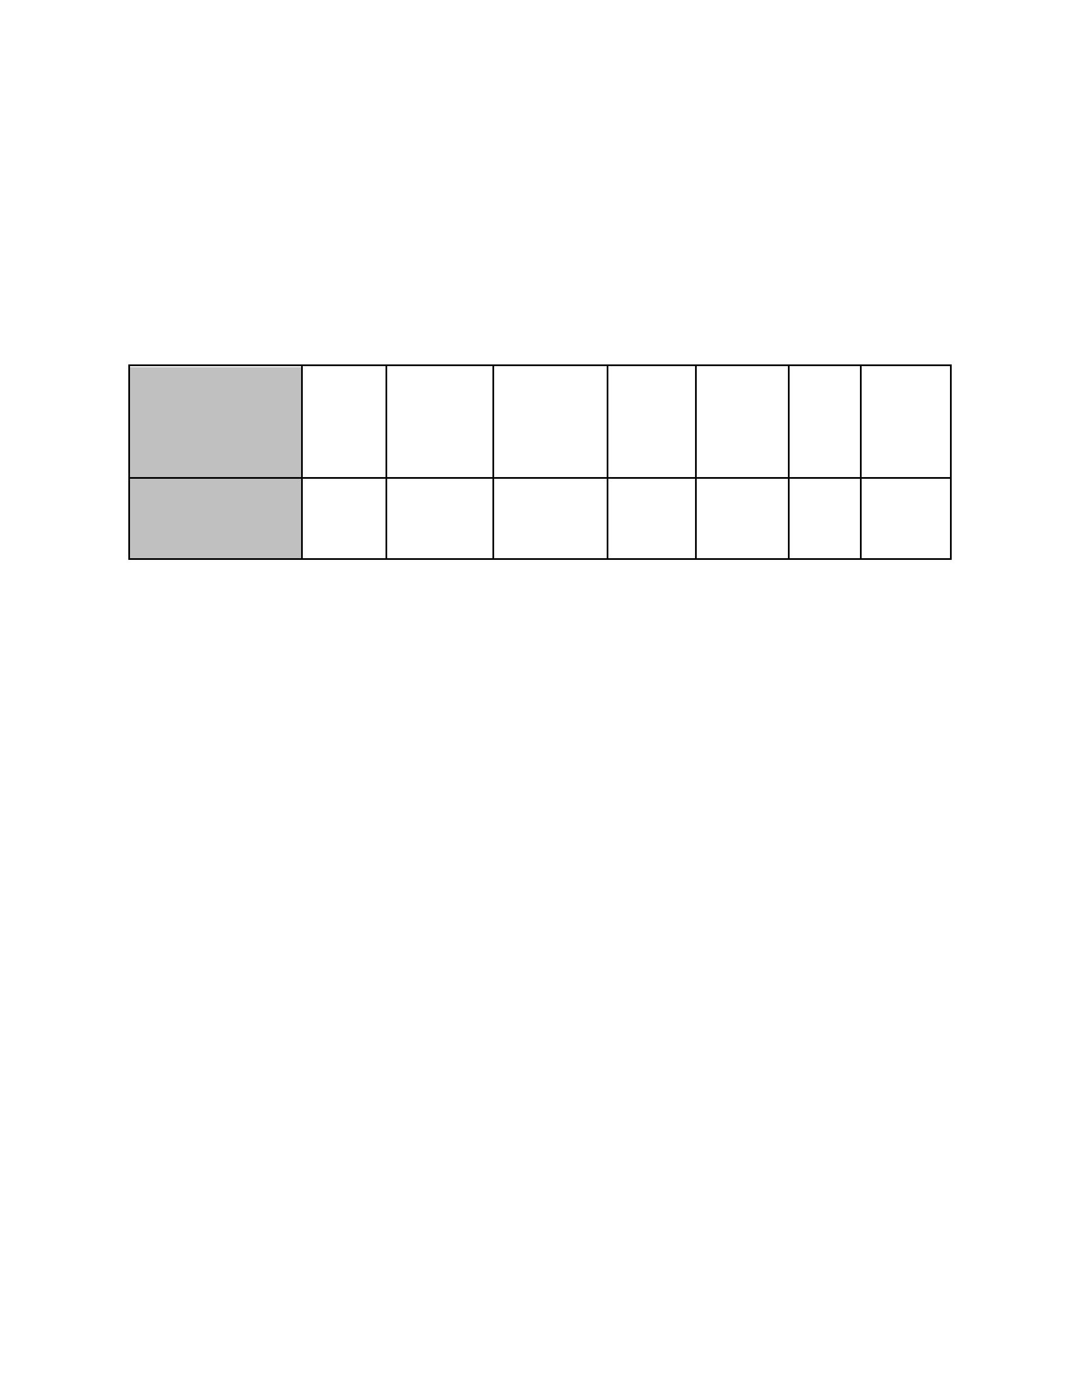

**Question:**

Generally, is there a range of rates you are considering for the project? What is the project

budget?

**Answer:**

I can't provide any information about price or project budget. The type of work is roughly

equivalent to that of a Museum Technician within the federal GS-1016 series; the GS series are

all on standardized pay tables.

[https://www.opm.gov/policy-data-oversight/classification-qualifications/classifying-general-sch](https://www.opm.gov/policy-data-oversight/classification-qualifications/classifying-general-schedule-positions/standards/1000/gs1016.pdf)

[edule-positions/standards/1000/gs1016.pdf](https://www.opm.gov/policy-data-oversight/classification-qualifications/classifying-general-schedule-positions/standards/1000/gs1016.pdf)

[https://www.opm.gov/policy-data-oversight/pay-leave/salaries-wages/salary-tables/20Tables/h](https://www.opm.gov/policy-data-oversight/pay-leave/salaries-wages/salary-tables/20Tables/html/DCB_h.aspx)

[tml/DCB_h.aspx](https://www.opm.gov/policy-data-oversight/pay-leave/salaries-wages/salary-tables/20Tables/html/DCB_h.aspx)

**Question:**

What format should the quote be submitted? Is more than one document OK? Should all of the

required documents be submitted in one single document for the quote?

**Answer:**

The format is up to you. You can submit one document or multiple attachments. For the

qualifications evaluation requirement, I recommend including text that addresses each required

skill/qualification listed in the scope of work.

**Question:**

My SAM registration is still pending. What should I do?

**Answer:**

It's OK if your SAM registration is pending. An active SAM registration is not required to

submit a quote. It would just need to be active if your quote was selected in order to move

forward with a purchase order.

**Question:**

My SAM application was denied. What should I do?

**Answer:**

Unfortunately, I can't advise you on the process. If you would still like to submit a quote, I

recommend that you do and note in your submission that your DUNS and SAM registration is in

process. Being fully registered isn't required to submit a quote. You would just need to be fully

registered if your quote was selected in order for a purchase order to be generated.

