Dictionary: 1,500 entries
Tlex exports Ok to XML but when there are too many entries, nor the British equivalences (GB) nor the definition (DESPA) are well exported into Excel.
From Tlex to XML, and from XML to Excel (all 1,500 entries):
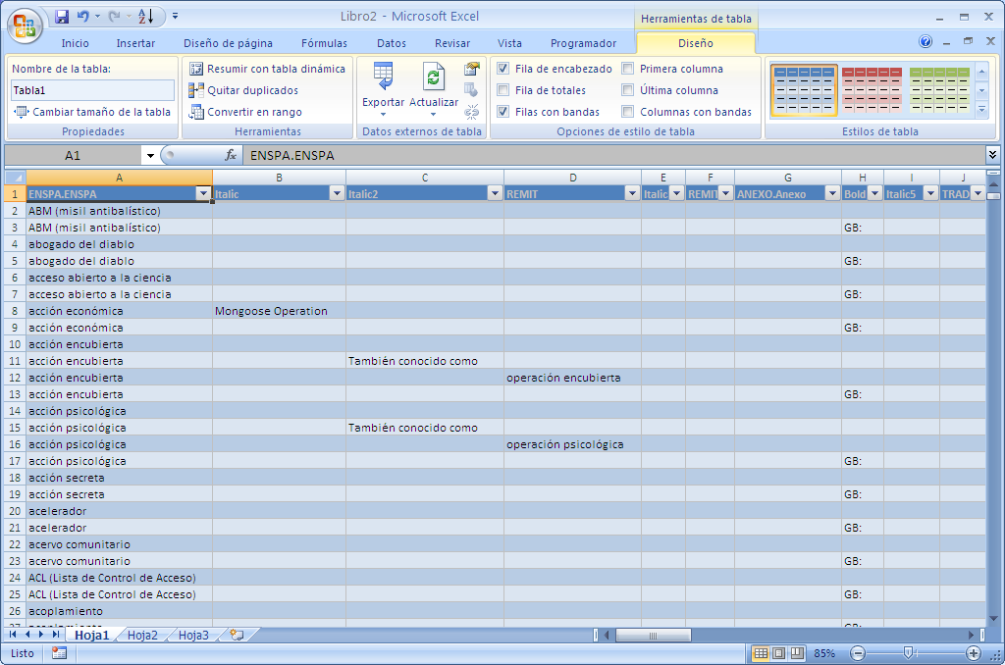

The strange thing is that after having deleted almost all entries except those 10 entries that I want to send you as a sample, the British equivalences do appear (but definitions still not):
From Tlex to XML to Excel (only 10 entries):
