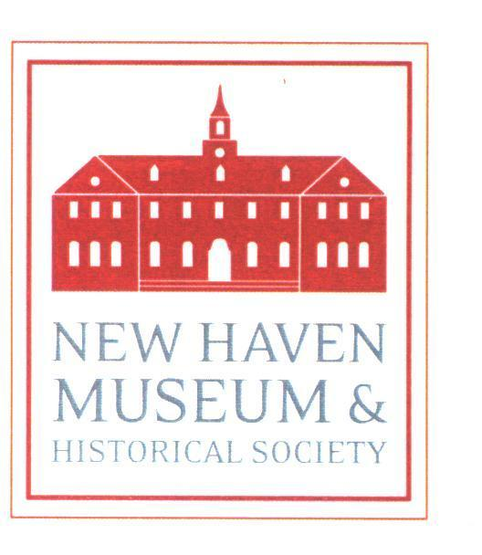

New Haven Museum & Historical Society

114 Whitney Ave. New Haven, CT 06510
203.562.4183 www.newhavenmuseum.org

NEWS RELEASE

Recent U.S. Poet Laureate & New Haven area native Donald Hall
Talk, Reading & Book Signing
Unpacking the Boxes: Memoir of a Life in Poetry

When: October 23, 2008 at 5:30 pm

Where: New Haven Museum – 114 Whitney Ave., New Haven, CT
Contact: Bill Hosley 203-562-4183 x 11 or info@newhavenmuseum.org

Cost Per Person: FREE - Donations Welcomed: $10 adults, $5 students

What: Talk, Reading, Book Signing, Reception with the Author

Unpacking the Boxes: A Memoir of a Life in Poetry by recent Poet Laureate of the United States, Donald Hall, speaks for language, ideas, and connectedness to place with eloquence and feeling. Best of all, one of Hall’s places is here in Connecticut. Raised in Hamden in and around the region’s once prominent Brock-Hall Dairy – his family’s business – Hall was also influenced by his maternal grandparents who occupied a multi-generational family farm in New Hampshire. Donald Hall’s life and work speak of a quality of New Englandism and what it means to be American. In Hall’s America agriculture conferred status and opportunity and is (or was) the basis for a life grounded in place and environment – a message that Connecticut needs to hear today as we grapple the consequence of sprawl and public policies that tax localism and common sense.

Hall’s memoir foreshadows a sense of loss as distinctions between urban and rural yielded to the sprawling leviathan of suburbia with its insatiable appetite for land and prolific abandonment of both city and country. Recalling the family farm in New Hampshire where his mother was raised, Hall describes a house where “the family’s history is preserved in . . . fragile quilts, broken chairs and mildewed books," where “Everything connected to the departed was preserved and cherished,” and where “Each trip I visited with my mother embodied a lost domain.”

Hall’s recollections are of an era when horse and wagon delivered ice; a father whose keen sense of geography was shaped by years delivering milk to the Hamden countryside; the Hurricane of 1938; summer adventures at Savin Rock; Red Barber and the Brooklyn Dodgers; covering high school sports for the New Haven Register, and more.

Youthful sexuality is explored with humor, verve and authenticity as we learn, among other things, what Middlebury College’s famous Breadloaf Summer Writing School was also famous for.

At the heart of the memoir is a life lived for poetry and writing including lifelong friendships with John Ashbery and Robert Bly whose “vatic, thundering poems” belong to the cultural affirmation and exuberance of post World War II America.

Like the best artist memoirs, Unpacking the Boxes reveals what art is made of and what a life in art requires.

A Special Limited Edition Broadside of Hall’s well known Connecticut poem, “The Sleeping Giant” has been printed on the occasion of Donald Hall's reading at the New Haven Museum; signed copies will be available for sale.

About the Author: Donald Hall was born in New Haven in 1928; he grew up in Hamden on Ardmore Street and attended local schools before going to Phillips Exeter, Harvard, Oxford and Stanford. Having begun writing books before his teens with poems and short stories, he then moved on to novels and dramatic verse. Hall taught writing at the University of Michigan until 1975, when after marriage to his second wife and fellow poet, Jane Kenyon, he left academic life to write and live in rural Danbury, New Hampshire. The author of many books of poetry and prose, as well as children’s books, Hall was named the 14th Poet Laureate of the United States, recipient of the Robert Frost Medal (1990) and three time winner of the National Book Award. His most recent books include White Apples and the Taste of Stone: Selected Poems 1946-2006 (2007), Eagle Pond (2007) and The Best Day the Worst Day: Life with Jane Kenyon (2006).
Program Sponsors: Houghton Mifflin Harcourt Publishing & Rvive Books
Directions: The museum is located near the intersection of Trumbull Street and Whitney Avenue in downtown New Haven. Abundant on site parking with overflow parking available at Yale Lot #23 on the opposite side of Whitney Avenue, just south of 155 Whitney (Yale Human Resources building).
About Us:
The New Haven Museum (founded 1862), the Elm City’s premiere civic museum and research center, provides a comprehensive introduction to the history and art of greater New Haven with changing and permanent exhibitions on New Haven Illustrated, the Federal Art Project in New Haven, Amistad, New Haven & the Sea, and local art, decorative arts and photography. The Museum offers an array of educational programs that use the galleries and a downtown location as a “classroom” for place-based, experiential learning both here and at area schools, senior centers, historical organizations, libraries, and prisons. The Whitney Library & Research Center is one of the oldest, largest and most unique civic libraries in Connecticut.

