STÉPHANE BOUQUET

Screenwriter / Poet / Translator / Critic / Dancer / Choreographer

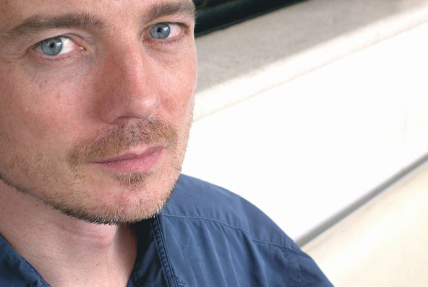

Stéphane Bouquet was born in Paris in 1967 from the brief love affair of a French nurse and an American GI.

He is the screenwriter of gay cult classics Come Undone and Wild Side, among eight other films. As a writer for Cahiers du cinéma, he published studies of filmmakers Pasolini, Eisenstein, and Gus Van Sant. His books of poetry travel incessantly between France and the US in search of a formula, if it exists, that would allow him to write American poetry in the French language. He is the French translator of Robert Creeley’s The Charm and Paul Blackburn’s Selected Poems.

TUESDAY, DECEMBER 7 // 7PM
483 College Street

Refreshments will be served.

