Poetry Reading
February 13, 2013

Katie Yates, adjunct professor of English at St. John’s University, Queens, NY lives in New Haven, CT with her family where she predominately sketches out her family. She is a meditation student in the Shambhala Buddhist tradition and holds degrees from Carleton College, The Jack Kerouac School of Disembodied Poetics, and the University at Albany. She is the author of poem for the house (Stockport Flats, 2012)

Photo: Michael Forstrom
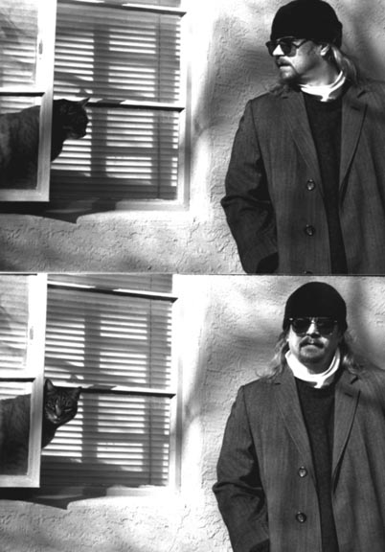
Robert Masterson, professor of English at City University of New York’s Borough of Manhattan Community College in New York City, has authored Artificial Rats & Electric Cats, Trial by Water, and Garnish Trouble. His work appears in numerous publications and he holds degrees from the University of New Mexico, the Jack Kerouac School of Disembodied Poetics in Boulder, Colorado; and Shaanxi Normal University, the People’s Republic of China.

Photo: Anna Patalano

The Infinite Well - 123 Court Street New Haven, CT
Open Reading at 7:30 p.m. & Free Parking

