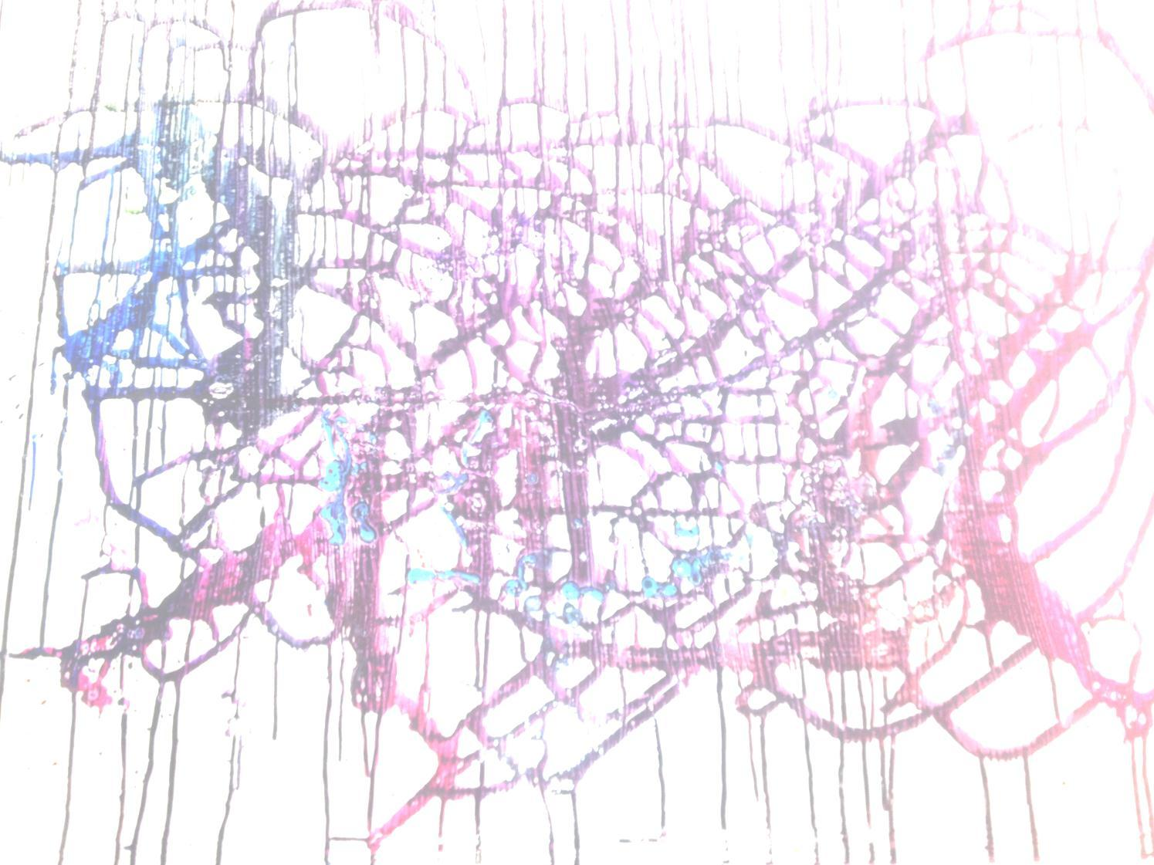 | Maxwell Clark & Thomas Wexler  Wednesday, 3 July 2013  The Infinite Well - 123 Court Street New Haven, CT  Open reading at 7:30 pm & free parking  the hands turning the words  mean less  than those giving them:  the rule  of labor
  Maxwell Clark - Winner of the 2013 Arkadii Dragomoshchenko Prize for Innovative Poetry, judged by Charles Bernstein. Published in Juked, Swans, Counterpunch and Short, Fast and Deadly.
  Thomas Wexler is responsible for blogs First Time Records and One Way Street Photography. He has contributed articles and reviews to several publications.
  .

