Setting up RLIN21 Latin Keyboard in Windows XP

- Download and install the RLIN21 Latin Keyboard from PC Amigo.

- Go to the Control Panel; click on Regional and Language Options:

.

- Click on the Languages tab, then click on [Details…]:
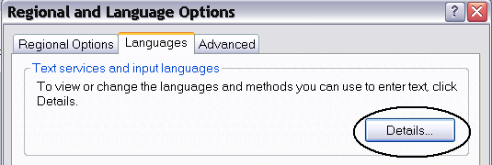

- On the Settings tab, click on [Add…]:

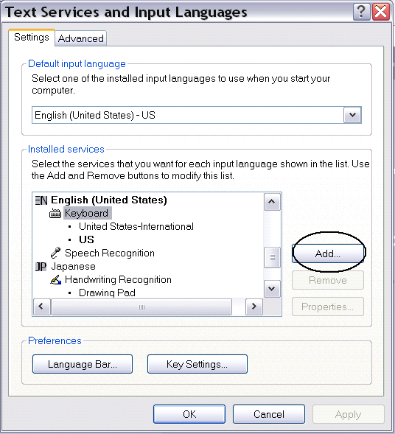

- Click on the drop down menu for “Keyboard layout/IME” to display a list of keyboards; select RLIN21 Latin Keyboard; then click [OK] until you exit the Regional and Language Options.
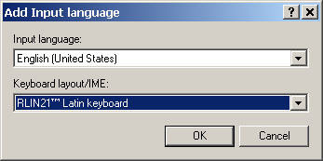
- You should now see a language bar located at bottom right hand corner of the desktop:

- To use the RLIN21 Latin Keyboard, click on the keyboard icon, then select the RLIN21 Latin Keyboard.” You can switch between different input methods by pressing the left <Alt> + <Shift> keys or the right <Alt> + <Shift> keys.

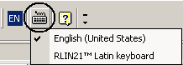

----------------------------------------------------------------------------------------------------------
Note:
- You may place the language toolbar anywhere you like by dragging it.
- You may also setup the language bar so that it shows the name of the keyboard you are using:

1. On the Text Services and Input Languages window, click on the [Language Bar...] button:

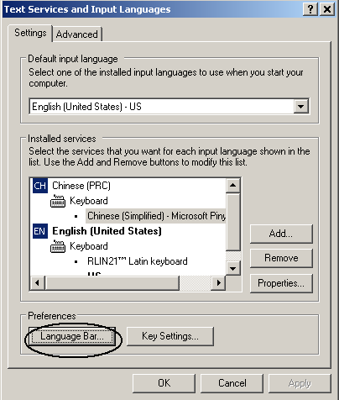

2. Check the “Show text labels on the Language bar” option:*

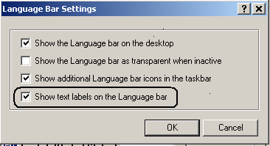

3. Your Language bar should now look like this:

* If the Language Bar Setting options are grayed out, on the Text Services and Input languages window, click on the [Advanced] tab and make sure that the System Configuration box is un-checked, click OK, then repeat steps 1-3.

