From Harvard U
- I catalog an edited work, and add a 505 for each article/paper. The LC training materials stated that I should also add a relationship entry for the first part of the whole compilation (i.e. a 700:12: for the first chapter.) However, when I looked in RDA I could not find the rule or LC/PCC PS to support this. Is this something that has changed since the training slides/manuals were written?
Answer (TC) - I don’t believe it is a change. See Module 4, "Relationships", slides 36-39.

Module 4, slide 36

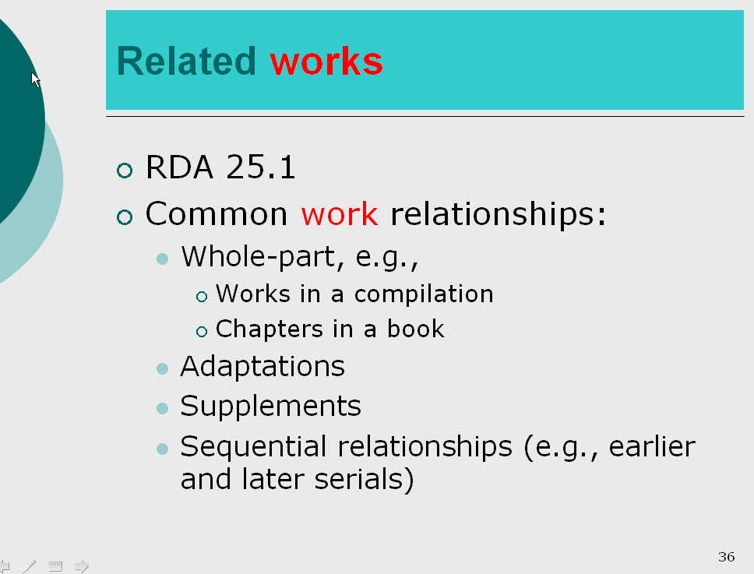

Module 4, slide 37

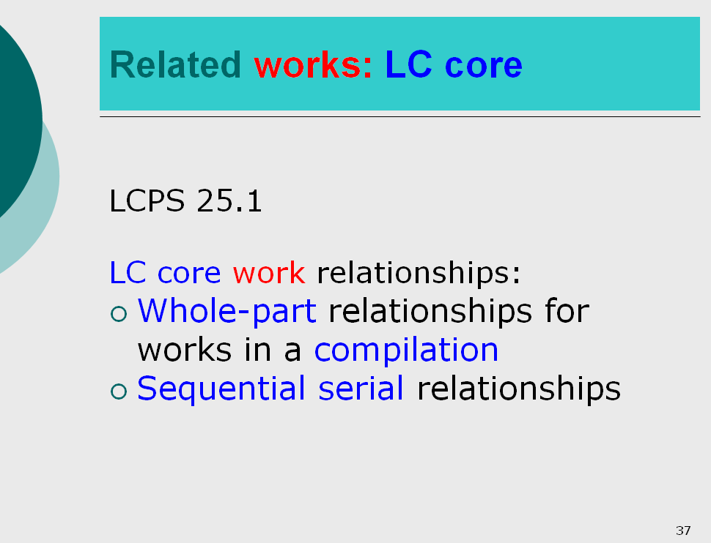

Module 4, slide 38

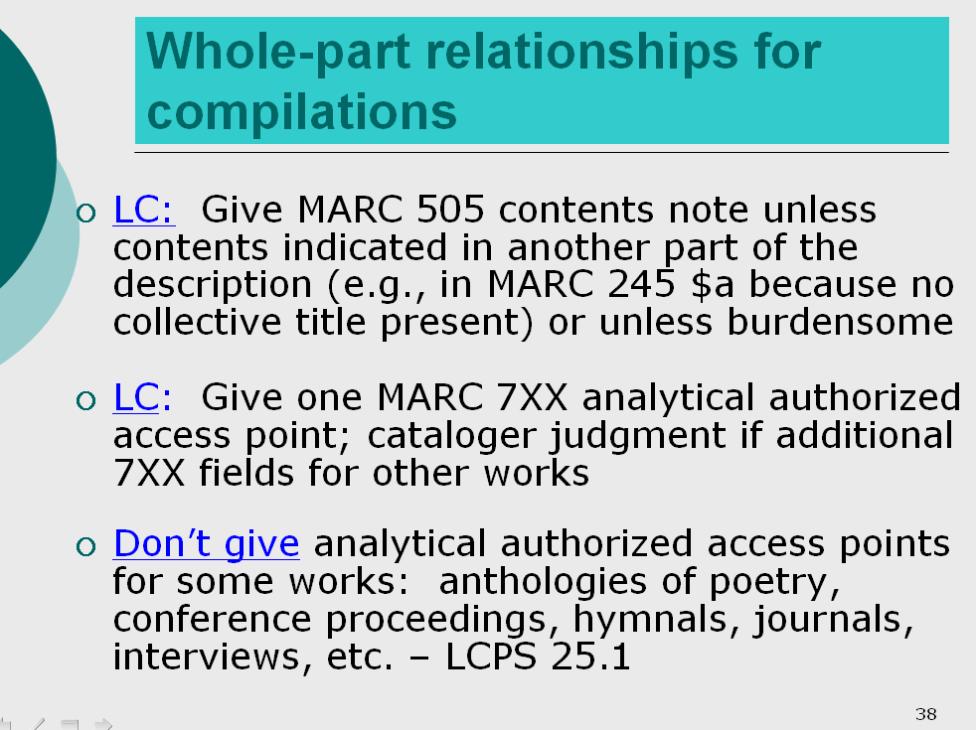

Module 4, slide 39

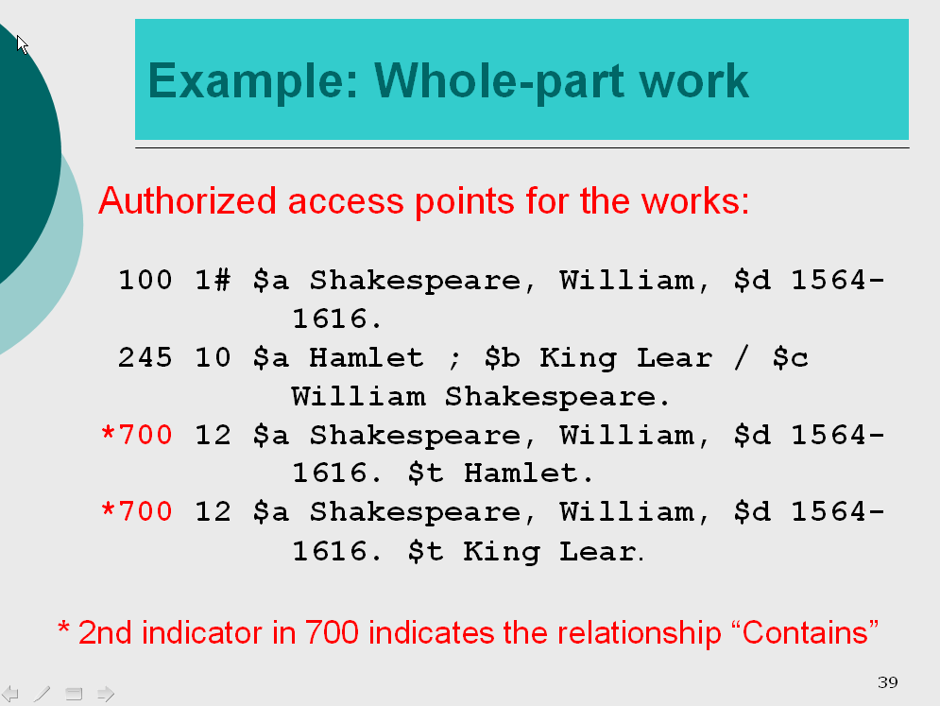

And these cite LC-PCC PS 25.1. In that PS, I encourage you to read carefully the introductory paragraph, which provides you two 'outs' if you think it is not appropriate in a particular case: it says "when it represents a substantial part of the resource" (use your judgment about the relative extent, 'merit', etc. of the related part), and there is the 'generally do not' disclaimer (with that useful 'and similar resources' clause). In other words, if you have a good reason not to give the access point, fine. Use your judgment. (BTW, even the 505 is at your judgment).
For more examples and exercises on this question, see also our "Guided Practice," Exercise 2.

2. Reprints/offprints of articles. Please provide some guidance for MARC coding for the larger work. In these cases, we are not cataloging the article. If we were, we understand that we would use a 773. However, we are cataloging another manifestation (the reprint) of the same work (the article.)
  - In AACR2 we would have used a 730 for the journal that the offprint/reprint was from, and we would not have included the volume designation, etc.
  - In RDA, would we use 787? Do you have any recommendations on which subfields we should code? I assume |a, |t, & |w would be the minimum, to allow patrons access and enable the computer to link these. Would the information regarding volume number, etc. be sufficient in a note? Or should we include it in the 787 instead? My understanding is that LC PCC would like to move away from notes and more towards recording these types of notes that deal with relationships in 7XX fields, using the subfield i when necessary. Is this correct?
  - Any guidance you can provide on offprints/reprints would be greatly appreciated.

Answer (with input from PSD staff): LC does not have a policy on which linking fields to use but RDA provides various options - cataloger judgment as to which linking entry field to use. Yes, LC is looking for greater use of the 7XX fields. 730 is a possibility plus an appropriate linking field. Here is a serial example, LCCN 2012204177 (perhaps not exactly what you are dealing with, but shows that appropriate 7XX fields could be used)

222 4 $a The Science & society reader $b (Online)
245 04 $a The Science & society reader.
730 0 $i Selected articles from: $a Science & society (New York, N.Y. : 1936)
776 08 $i Also issued in print as: $t Science & society reader $x 2324-9196 $w (DLC) 2012204176 $w (OCoLC)811604357
787 08 $i Selected articles from: $t Science & society (New York, N.Y. : 1936 : Online) $x 1943-2801 $w (DLC) 2008201925 $w (OCoLC)47766701

3. According to LC/PCC PS 7.9.1.3 we record dissertation information in a 502 (formatted) or in a 500. I have the following example from an RDA record that I created:
500: :Originally presented as the author's thesis (doctoral--Rheinische Friedrich-Wilhelms-Universität in Bonn, 2006) under the title: Die ärztliche Sicht auf menschen mit Down-Syndrom von der Erstbeschreibung durch Langdon-Down (1828-1896) bis in die Gegenwart.

However, wouldn’t it be better to put this information into a 775, so I could link to the bibliographic record for the original thesis? I am just wondering if this should be listed as an option in the LC/PCC PS. A follow up question is: if I add the 775, do I also need the 500? My understanding is that we are trying to move away from redundancy in the MARC record, but I may be wrong about that.

LEH: As you point out unstructured 500 notes and 502 structured notes are the two methods given in RDA for providing information about dissertations. Could the relationship be considered related works? I am not sure that that 775 (other edition entry in MARC 21) is appropriate-but you make a very good point that a structured linking entry might be ideal for this type of information.

4. I have a question about works that are related to other works. I have a book that was published in 1999, as a companion to a VHS video recording that was published by a different publisher in 1998. I cataloged the print work below:

040 OHX $b eng $e rda $c OHX $d OCLCQ $d HEBIS $d YUS $d TOZ
0167 963416723 $2 DE-101
020 392943976X (hd. bd.)
020 9783929439762 (hd. bd.)
...fields deleted...
24504Die Neandertaler, Feuer im Eis : $b 250,000 Jahre europäische Geschichte / $c herausgegeben von Elmar-Björn Krause ; mit Beiträgen von Gerhard Bosinski, Winfried Henke, Herbert Ullrich, Hannelore Bosinski, Cornelia Hackler, Elmar-Björn Krause, Michael Fasterding, Peter Hardetert und Axel von Berg.
250 1. Auflage
264 1Gelsenkirchen : $b Edition Archaea, $c 1999.
300 160 pages : $b illustrations (chiefly color), color maps ; $c 25 cm
336 text $b txt $2 rdacontent
337 unmediated $b n $2 rdamedia
338 volume $b nc $2 rdacarrier
504 Includes bibliographical references (pages 154-157).
50500$t Einleitung / $r Emlar-Björn Krause -- $t Charles Darwin - Wegbereiter der Evolutionstheorie / $r Michael Fasterding -- $t Plumpe Bestien oder ebenbürtige Artegenossen? Zum Erscheinungsbild der Neandertaler / $r Winfried Henke -- $t Weichteilrekonstruktionen von Neandertalern - Fiktionen und Fakten / $r Winfried Henke -- $t Datierungsmethoden - Grundlagen der Geschichte / $r Cornelia Hackler -- $t Das Phänomen der Eiszeiten / $r Cornelia Hackler, Peter Hardetert, Elmar-Björn Krause -- $t Das Mittelpaläolithikum / $r Gerhard Bosinski -- $t Kult und Religion / $r Herbert Ullrich -- $t Konnten die Neandertaler sprechen? / $r Cornelia Hackler -- $t Meinungen der Forschung -- $t Zum Schicksal des Neandertalers / $r Winfried Henke -- $t Drehscheibe Naher Osten / $r Elmar-Björn Krause.
…fields deleted…
7001 Krause, Elmar-Björn, $e editor of compilation.
70012Fasterding, Michael. $t Charles Darwin - Wegbereiter der Evolutionstheorie.
78708$i Companion to film: $t Feuer im Eis $d [Mainz] : ZDF, 1998. $w (OCoLC)313405632

My question is about the 787. Is that the correct field to use for this sort of related work? Also I came up with the text in the 787 |i (i.e. I did not find the text in RDA.) Is there another phrase I should be using here? If not, my understanding is that I need to submit this phrase to LC/PCC. Please let us know the process for submitting new relationship designations.

LEH: I think that 787 provides the opportunity to specify the relationship using the $i as you provided. 787 is kind of a catch-all linking entry field. As far as a more appropriate term, it looks like you have looked at the terms and definitions in the appendix before deciding to apply your own term that is good. In appendix J.2.5 I saw another possibility, "complemented by (work) A work paired with another work without either work being considered to predominate. Reciprocal relationship: complemented by (work)" I don't know if that would fit, maybe not.

If you find you need to use another designator not in the appendices, use it. For now PCC members can suggest terms for the RDA appendices by sending them to the chair of the PCC Standing Committee on Standards who will send the suggestion to CC:DA and from there on to the JSC via the CC:DA representative to JSC. Be sure to include a specific definition of the preferred term, definitions of any reciprocal terms, and any variant terms. The PCC is considering other ways to handle suggestions for relationship designators, but for now send suggestions with as many details as possible to Becky Culbertson, chair of the PCC Standing Committee on Standards rculbertson@ucsd.edu.

300 160 pages : $b illustrations (chiefly color), color maps ; $c 25 cm

You may also notice that the 300 |b is filled in. Although this is not core in RDA, this information was already in the record as “|b col. ill., col. maps.” I expanded the abbreviations, and changed it a bit since some of the illustrations are not in color. I did not want to remove the information. However, I used the sort of phrasing that we used to use in AACR2 to indicate that the illustrations are chiefly in color and that there are color maps. I did not see anything in RDA that said I could not do this. Please let me know if this is incorrect.

LEH: I think this conversion of terms in the 300 field is ok.

5. I understand the rules for compilations, how you provide an authorized access point for creator/title for the predominant work (or first-named in the contents note). What if the record for the compilation represents an analyzed-work-in-parts, for example, the set record for an author's complete works? Or the set record for, say, a work concerning archaeological dig, each of which has an independent title and separate author? If the decision has been made to analyze the individual volumes, do you still need to provide at least one analytic on the parent record for the purposes of pcc cataloging? If so, would you just take that analytic out locally to prevent a redundant hit in the OPAC for that analytic title? I couldn't find anything in RDA describing this situation under analytical description, but, maybe I missed it.

LEH: This is an interesting question, let's discuss during the webinar and get input from other attendees.

From PSD: The requirement to provide an analytic for the 1st work in a compilation is an LC core element, not an LC/PCC core element (see 25.1). As LC does not create collected set records when the individual resources are analyzable, we would not address this in our training. For a PCC library doing this, the relationship between the collected set record and the individual analytic would be expressed through an authorized access point for the series. Remember that RDA does not prescribe one method for expressing these relationships. The LC-PCC PS 25.1 instructions about a contents note and an analytic for the 1st/predominant work are two of several ways to express the whole/part relationships.

From Cornell
1. When we first started creating RDA records, we were quite faithful about making analytical access points for the predominant or first work/expression in a compilation. As time has gone on, more and more of us have been invoking the judgment clause about “when it represents a *substantial* part of a resource” for ordinary compilations that aren’t conference proceedings but which have a bunch of academic essays, all relatively equal. Doing the authority work on the first name can be seen as burdensome. What would you recommend?

LEH: I think it is important to use the guidance in LC PCC PS 25.1 as written “For compilations of works, give an analytical authorized access point for the predominant or first work in the compilation when it represents a substantial part of the resource.” If you’ve decided there is no predominant work and that the first work does not represent a substantial part of the resource, then ok don't give an access point. But LC's practice is to be sure to give an access point if there is a predominant work or first work when it does represent a substantial part of the resource.

2. Is there a good relationship designator subfield j term in the works for what we used to call conference main entry? Right now we are leaving all 111s without any relationship designator.

LEH: Great question, have heard others discuss how a creator relationship for a conference could be shown with relationship designators, and I know there is great interest in finding appropriate terms. But I don't have a good answer. It seems to me a discussion on the PCC email discussion lists might be useful, any ideas for terms can be submitted to the chair of the PCC Standing Committee on Standards as mentioned above.

3. In making 505 contents notes for multi-volume works, do we transcribe the volume numbering on the pieces (e.g. “volume 1”) or apply the abbreviations in Appendix B (e.g. “v. 1”)? Does B.5.5, Numbering of a Part (“a designation of the sequencing of a part or parts within a larger work”—24.6.1.1) apply, or is 24.6 only for authorized access points for series?
LEH:

1) Please see: LC-PCC PS 25.1.1.3 REFERENCING RELATED WORK Formal Contents Notes (Structured Descriptions).

“…Give the volume designation that is found on the resource; separate the volume designation from the title by a period-space…”

There is a lot of information in this LC-PCC PS.

2) Yes I think B.5.5 and the reference to 24.6 refers to authorized access point for series.

4. On slide 44: Example 1: Whole-part expression
The slide has both a 505 0# and 740 02 for the parts. If the cataloger chose to use an enhanced 505 (505 00 $tOut stealing horses -- $tTo Siberia), would that make the 740s redundant? Is there any reason to prefer the format used in the example over the enhanced 505? It seems like more work for the cataloger with no added advantage for the user.

Module 4, slide 45
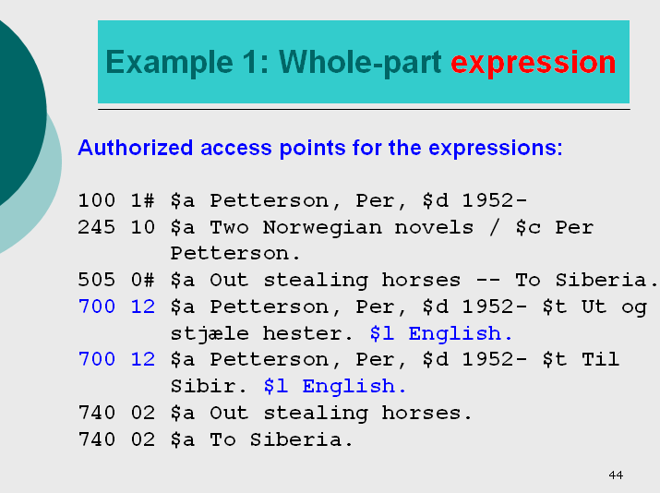

LEH: Adding a 740 would be entirely up to the cataloger and given only if for some reason it was thought it would help the user, in this case by providing an uncontrolled title access point. It might be useful for some catalogs depending on indexing. But you are the best judge of how to provide the best access to users of your catalog and it sounds like the 505 is the best approach for your catalog and users.

5. In reference to the same slide (slide 44): the LC-PCC PS for 6.2.2.10.3 says: Instead of recording the preferred title for each of the works in the compilation, record a conventional collective title followed by "Selections." Give an authorized access point for the first or predominant work …

In view of the LC-PCC PS, why does this example lack a 240 with a conventional collective title (i.e., Novels. Selections. English)? Is it because the PS refers to works and the example on slide 44 is a compilation of two expressions? Would such a conventional collective title for this compilation of expressions be incorrect?

LEH: I think you are right a conventional collective title could/should be added to the example as you suggest. I would like to consult with colleagues to verify and update the slide.

6. Slide 45: Structured descriptions for related expressions

Module 4, slide 45
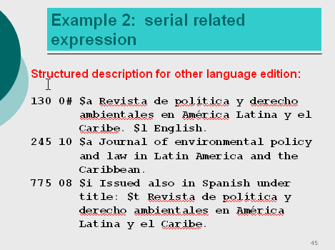

The example gives a 130 and a 775 for the Spanish language version of a journal.

We frequently see monographs that are (re)publications of doctoral dissertations. What is our obligation to represent the original thesis?

Examples:
1. Brunner, Martin. Parliaments and legislative activity, t.p. verso: Zugl. Dissertation der Universitat Konstanz
2. Diehl, Alexandra. The core standard of international investment protection. Dissertation of Julius-Maximilians-Universitat Wurzburg, acknowledgments: “this book is an updated version of my doctoral thesis”

3. Vriesen, Vera. Amnesty justified? “This volume is an adapted version of a dissertation defended at Tilburg University on 16 December 2011)

It is clear that we should include a note referencing the dissertation (500 ## Originally presented as the author's thesis (doctoral) …). Should we also be including a 775 referencing the original dissertation? If we do this, should we also be including a 240? In the examples, none of the works gives the title of the actual dissertation. Also, we have no way of determining the extent to which the content of the version we are cataloging differs from the original thesis.

In researching the author of the first example to establish him, we discovered that the work was issued under a different title as his dissertation (work in hand: Parliaments and legislative activity: motivations for bill introduction; dissertation: Much ado about nothing? An analysis of parliamentary bill introduction).

We don’t want to spend time researching each of these types of publications, but if the information has come up, ought we to include it?

LEH: LC-PCC PS 7.9.1.3 provides instructions for Recording Dissertation or Thesis Information- and the guidance there is focused on 500 and 502 fields. Are linking entry fields appropriate? Good question. I wonder about using 775 "other edition entry" and wonder if in some of the situations you mention are more related work than expression relationships. Probably need to explore more with PCC colleagues, since this question comes up often.

7. Slide 67 shows the use of |w “a” and “b”, slide 68 explains the LC policy as being cataloger judgment for using |w and “r” and “i”. Ana Lupe Cristan’s presentation about relationship designators in RDA name authority records lists LC policy as being code “r” and “i”. What is the preferred method?

Module 4, slide 67
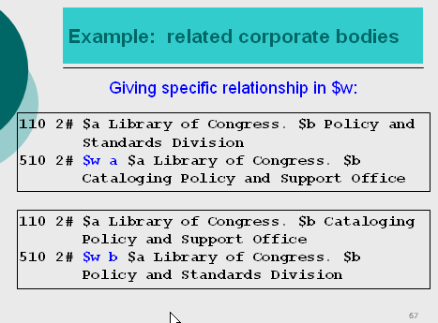

Module 4, slide 68

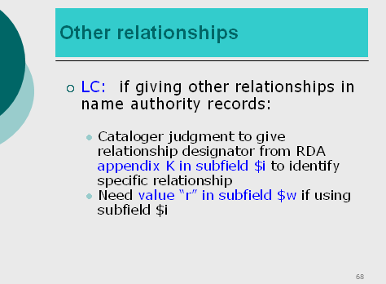

Answer (ALC): With regard to question 7 please look at slide 13 of Ana Lupe Cristan's presentation that clearly states that LC will use $w for earlier later

Special Topic Relationship Designators, slide 13
(http://www.loc.gov/aba/rda/source/special_topics_relationship_designators.ppt#642,5,Relationship designators (29.5) - Appendix K)

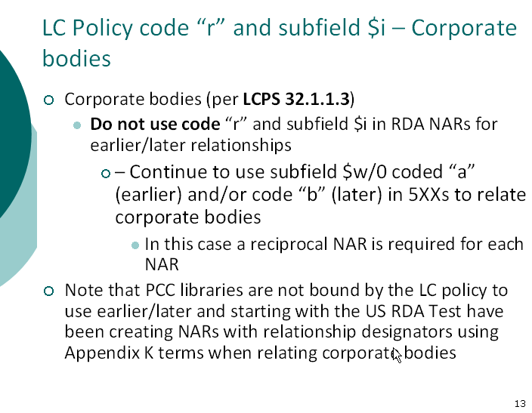

LEH: Take home message: PCC institutions are not bound by LC policy.

