From University of North Carolina, Chapel Hill

1. If you only have one type of illustrations such as maps, are you still required to use illustrations? Would it be okay to use maps instead? In AACR2 you had that option of choosing the term if there was only one type of illustration.

TC -- The LC-PCC PS says "generally" do not record the type of illustration. That does not mean you are FORBIDDEN from doing so if you judge it useful. Also, see 7.15.1.4
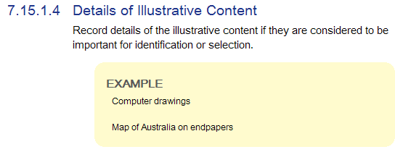

2. From Northwestern:
760-787 fields: Current CONSER policy is not to use subfield $7 in this field. Is there a policy either allowing or prohibiting its use in BIBCO records?

Answer from PSD: No, BIBCO has never made a statement about it-- I know LC practice has been to not use it, but the linking entry fields are pretty new to the mono world, so that's probably why a statement has never been made. I'd follow the CONSER policy (the LC-PCC PSs do refer to the CONSER practices for linking fields already, in LC-PCC PS 1.7.1, section on "Bibliographic Linking Entries."

It's also true of the 533-- I don't think folks have commonly used the $7 there, either.

3. Slide 44, "Whole-part expression": In the example of "Two Norwegian novels", given the LC interpretation of 6.2.2.10, wouldn't the authorized access point for this include:

240 10 $a Novels. $k Selections. $l English

TC -- Novels. Selections. English. Note that the slide is intended to illustrate the a.a.p.'s for the individual expressions, not the preferred title.

Module 4, slide 44
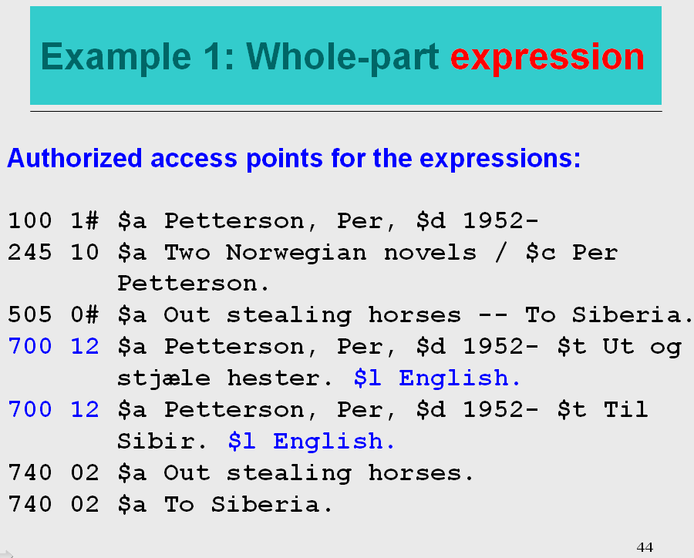

4. Slides 47-48, "Related expression - translation": Are the publication details appropriate here? If so, would we have to make sure we put the *original* publication information? The translation is based on the original work/expression, not on the manifestation, correct? Linking fields not only indicate WORK and EXPRESSION relationships, but also explicitly indicate MANIFESTATION relationships as well.

From UC Berkeley:

Re. related expression - translation (slides 47-48): Since the relationship being recorded is one between *expressions*, I don't understand why, using a structured description (MARC field 500 or 765), one would record *manifestation*-level data such as edition statement, publisher, extent, etc., as shown in examples 4 & 5. Could you please explain why this is done?

From Arizona State U

Slides 46-49 discuss translations of works and we’d like some clarification/verification of policies. The slides all show translation notes in a 500 field; we should continue to use a 546 for languages present in the item, is this correct? Also, are we correct in thinking the access point for a related expression (translation) is required, but the note, regardless of how formulated (500, 765), is optional? (Under AACR2 we were not required to add the 500 note if we had the 240.)

Answer 1 manifestation elements: The three slides 46-48 were intended to demo the possible ways to show relationships in our current bibliographic environment. You could choose one of them to make that relationship. You are correct the methods we use to code structured descriptions combine authorized access points for works and expressions and manifestation elements. Not the best of examples, I think. Probably better to have more discussion about when certain approaches would be more appropriate (e.g. use linking entry when showing relationships between print and online manifestations – use authorized access points for works/expression relationships)

The method shown on Slide 46, example 3 is probably a better choice to express the relationship:

700 1# $i Translation of: $a Brown, Dan,
$d 1964- $t Digital fortress.

Answer 2 continue to use 546/041?: Yes, that would not change in creating a record based on the manifestation in hand. The purpose of providing the authorized access point for the original language ed. (Dan Brown’s English in the above examples) is to make the relationship explicit. And this is optional for translations and language editions- there are very few required relationships so far in PCC practice.

Module 4, slide 46
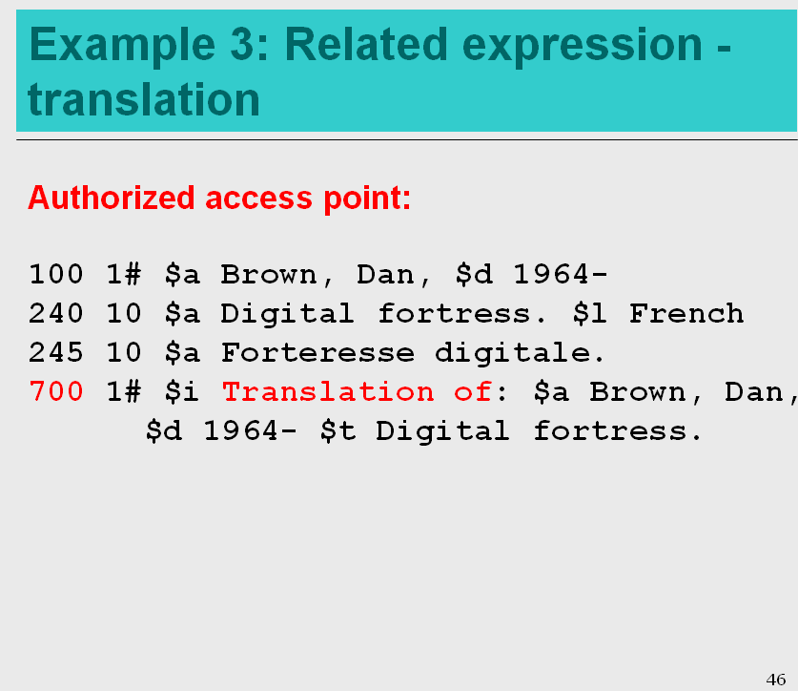

Module 4, slide 47

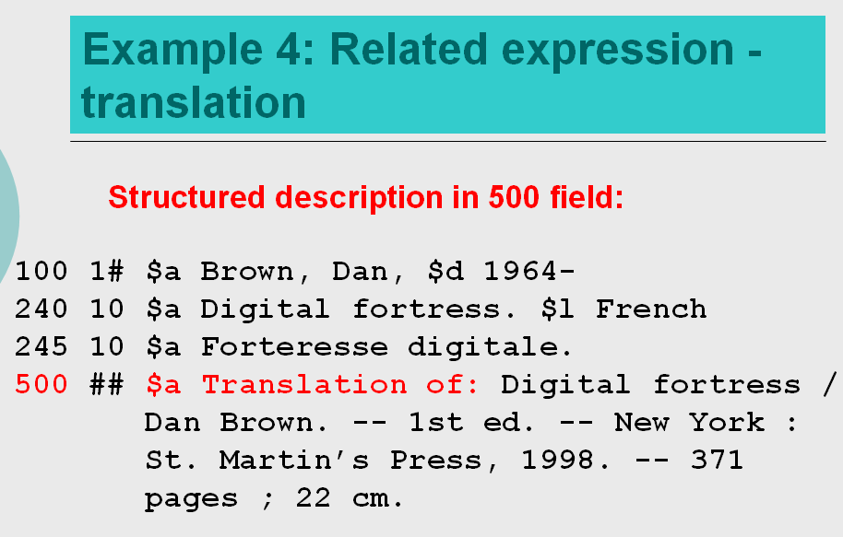

Module 4, slide 48

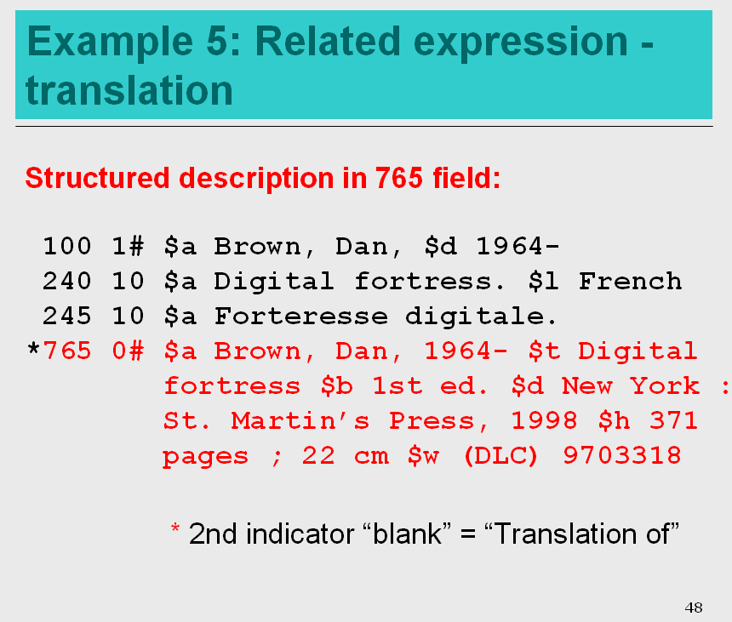

Module 4, slide 49
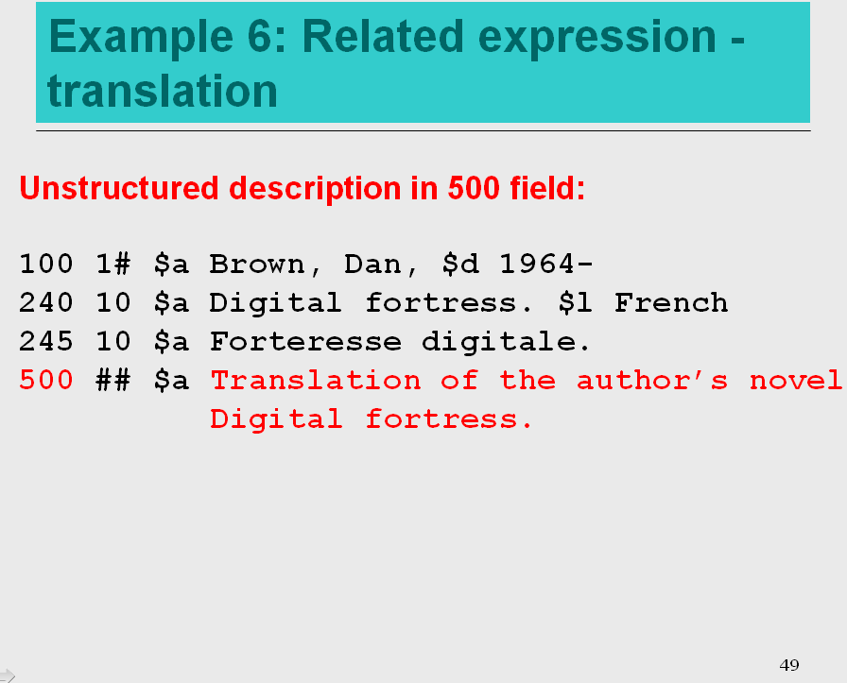

2. If a creator entity is part of the authorized access point for a work/expression (i.e. named in MARC field 1XX), *must* the relationship designator (or at least one of them if more than one is used) be taken from I.2.1? or can a term from one of the other lists in Appendix I be used?

Answer: Basically yes, in our implementation of RDA we are considering 1XX fields to represent a creator, so definitions of terms you use from Appendix I should reflect a creator relationship. It is possible to combine designators from different WEMI levels in one MARC 21 field, e.g. 100 ...., $e author, $e illustrator. This is a recommended practice in the PCC TG on Relationship Designators, repeat $e in these cases rather than repeating an entire access point. Also note that though we haven’t required a creator term when using 1XX (because our implementation infers that entities in 1XX are creators) the TG report recommends always providing a relationship designator when providing an authorized access point for a creator.

3. (not exactly an RDA question) Is 007 now required in bib records for all resources?

Answer (as heard on the webinar—see later response below) : The January revision of the PCC RDA BIBCO Standard Record (BSR) Metadata Application Profiles carries separate pages (pages 18-37) showing the “Required Non-RDA and MARC Data” for all types of materials. All ten types of materials require 007/00 Category of material, an d007/01 Specific material designation. Additional 007 fields are required for Archival materials, Audio recordings, Cartographic resources, Graphic materials, and Moving Images. Cartographic resources, shown below, has the most required 007 fields.

Variable Control Fields – Physical Description Fixed Field
Category of material |  | 007/00
Specific material designation |  | 007/01
Color |  | 007/03
Physical medium |  | 007/04
Type of reproduction |  | 007/05
Reproduction/reproduction details |  | 007/06
Positive/negative aspect |  | 007/07
Answer received after the webinar:
The 007 is only required "if applicable to the resource being described" and is not applicable for textual monographs unless secondary resource characteristics (such as accompanying material) need to be included.

The 007 is included under non-RDA MARC requirements for textual monographs because of microform materials. "Use “h” for microform textual monographs."

It is NOT required for a printed book.

4. I've come across what appears to me to be a discrepancy in instructions for recording titles. In particular, the section of 2.3.2.6 that begins "When preparing an analytical description ..." instructs to record the title of the particular piece being described as the title proper, and to record the collective title as a series title. This would seem to contradict 2.3.1.7, which instructs to record as the title the common title followed by the section title.

I hope I'm missing some subtlety in difference between the two, but as I currently read it, they appear to conflict. Can you please advise on this topic?

Answer: Perhaps these are two different kinds of whole/part materials.

2.3.1.7 talks about a separately issued section of something larger, and there are names for both the larger resource and for the part.

2.3.2.6 talks about a collection of things that appear in one resource, and there are names for both the larger resource and for each of the contents.

LEH: 2.3.1.7 carries over practices for making decisions about common title/section titles for continuing resources (AACR2 12.1.B4, 12.1.B6) . I think that 2.3.2.6 instructions on making an analytic description carry over instructions from AACR2 13.3 analysis of monograph series and multiparts.

The distinctions in 2.3.1.7 I think are particularly applicable to continuing resources (and certainly in some mono series and multiparts mentioned in the LC-PCC PS here). It focuses on separately issued, often numbered parts, sections and supplements. These types of resources sometimes vary in how the parts, part number, and common title are presented, it tells us how to construct the title proper if both appear on the preferred source of title.

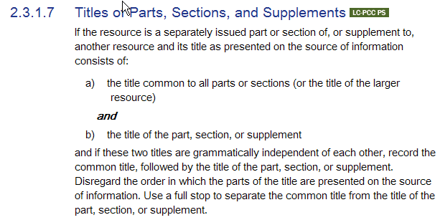
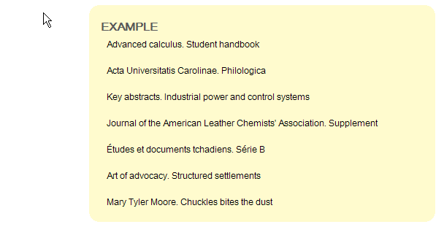

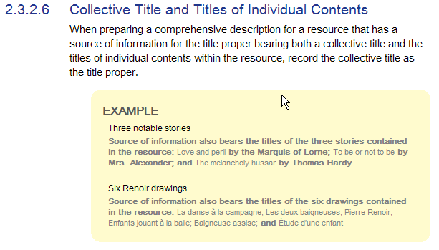

5. Relator terms and added entries. What's the appropriate use of relators terms with regard to author/title added entries?
a) 7001x$a. $e. $t
b) 7001x$a. $e. $t. $e
or
c) 7001x$a. $t. $e

Answer: None of the above. We wouldn’t use $e with name title authorized access points.
When you are making a name title entry you are citing a related expression or work. The terms are from appendix J, the MARC 21 subfield is subfield “i” so the construction is more like:
700 1# $i Translation of: $a Brown, Dan, $d 1964- $t Digital fortress.

From the University of Oregon

1. Slide 41: We are curious about when (or if) work-to-work relationships such as the one in this slide (relationship between the play and the motion picture) should be made in bibliographic records rather than authority records.

Answer: We are relying on the bibliographic record to do a lot of things, authorized access points for works and expressions are constructed there, not always with a corresponding NAR, we are expressing relationships among people, works, manifestations, items in the bib record. It seems ideal to me (and maybe less confusing, more orderly, less cluttered with manifestation related data) that the authority record is used to express this work to work relationship.

Module 4, slide 41
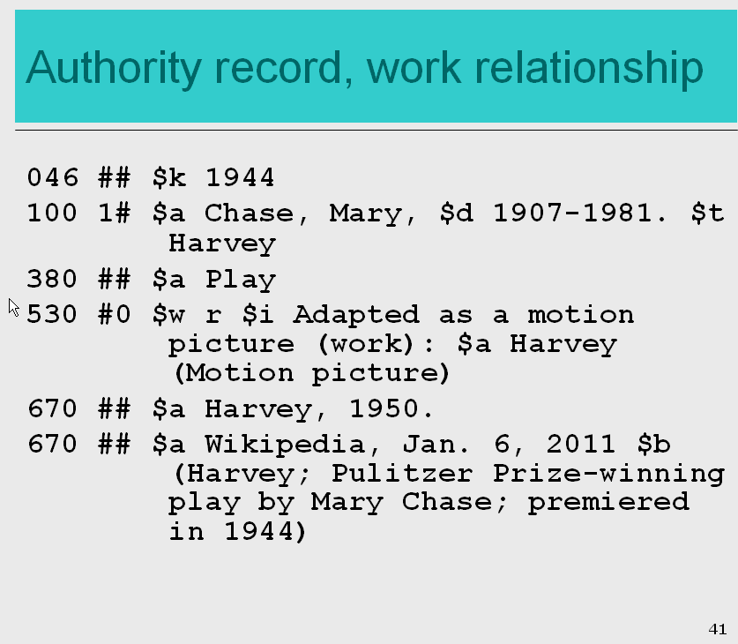

2) We understand we should have separate access points for works that contain multiple expressions, e.g., the original language and a translation published together. We often run across works initially published in two or more languages, such as photography books. While one of the languages is/must be a translation of the other, this doesn’t seem to be the same as works containing two expressions. Are we correct in assuming we would have a single authorized access point (100/245) for these items? For example, if we had a work by Artist A, with a title in English & German, we would have:
100 1 Artist A.
245 10 English title = $b German title / $c Artist A.
246 31 German title
Would we have to determine which language was the original language, which the translation, and add 700 fields, as well?

Answer: See LC-PCC PS 6.27.3: When two language editions are in a compilation, provide analytical authorized access points for each expression. If a compilation contains more than two language editions, give analytical authorized access points for the original edition and at least one other edition. If the original edition has not already been selected on the basis of one of the editions having been received earlier (see Policy Statement 6.2.2.4), select the first one in the compilation as the original edition for purposes of choosing the preferred title for the work.

Also:

Answer: [From Ana Lupe Cristán’s RDA Special Topics: Compilations and Collaborations, available from: http://www.loc.gov/aba/rda/Refresher_training_dec_2011.html ]

RDA says to name each expression – so this means we need to add in this case [case below] two analytical authorized access points ( 700 12 for both the English and the Spanish language expressions. We would not add a 240 to the bibliographic record. Subfield $l for the language was only added to the non-English expression. Note that until June 2012 we would have not only given two authorized access point 1) for the expression in the original language (English) and 2) one for the expression in the other language (Spanish) – but we would have added the language to both - but now you see we do not add the language to the authorized access point of the original expression.

