From Yale

1. Is there a briefer form of LC PCC PS in general use? I'm going to use PS in the rest of the questions.
Answer: No official briefer form, but I like your plan!

2. PS 2.8.6.6. A2. (No publication date; the copyright date is for the year following the year received). Instruction: base the publication date on the copyright date. Cataloger question: why not the year received?

Answer: In the example given in A2, if the date received were given [2008] the resource in hand has printed in it ©2009. The inferred [2009] publication date at least matches a date that is represented on the resource.

JZ: It is a lot more accurate to use copyright date as a supplied publication date than the date the resource was received. Say the copyright date is 2009, and the publisher intended to have it published by end of 2009, but for some reason the item did not come out of the printer until three years later in 2012 which is the year the resource was distributed and received. In this case 2009 the copyright date is a much more reasonable guess than the date when the item was received.
PSD comment: LC originally had the year received in the PS, as the questioner indicated made sense. We changed our policy because the PCC asked us to when they reviewed the PSs—their argument was that only the folks that also knew when it was received would be sure the record covered their resource, and someone who received it 5 years later would only know the copyright date and wonder if they were using the correct record.

3. PS 2.11 & PS 2.8.6.6. From the examples in the PS, if there is a bracketed publication date inferred from the copyright date, a 2nd 264 _4 is optional. On 2.11." Record a copyright date for a single-part monograph if neither the date of publication nor the date of distribution is identified." Just wanted to confirm that this means that in the case of a bracketed date of publication inferred from the copyright date, the publication date is considered to be "identified," so the copyright date is optional.

Answer: Yes

4. [I hope this is coherent; it came up as a result of a local RDA training class] A number of questions on treatment of dissertations when following RDA. At Yale, we create full cataloging for some of our dissertations (they are mostly handled as minimal cataloging, but we do full cataloging at the request of some Yale departments), and we generally perform full cataloging of other universities' dissertations if there is no fully cataloged record in OCLC. In all cases, what is cataloged is a reproduction of the original manuscript (even the Yale dissertations). The fully cataloged Yale dissertations are the service copies, and are usually photocopy reproductions. The dissertations of other universities are generally print on demand photocopies purchased from ProQuest, but in some cases are microfilm copies generally obtained from ProQuest.

a. When applying RDA, the reproduction itself is being described (1.11), unlike the LCRI practice of describing the original of the reproduction with a note about the reproduction. In the case of dissertations, since the original was understood to be the source of the description, it was coded in the MARC leader as a manuscript, coded as unpublished in 008, and only a production date was entered in 260. Question: Under RDA, it's my understanding that the reproduction is considered to be published. Is this the general understanding?
Stanford: That is our understanding. We have been treating print-on-demand disserations to be published and using the print-on-demand company as publisher, i.e. 264 _1 $a Ann Arbor : $b UMI

JZ: In 2.8.1.3, it says: When describing a facsimile or reproduction that has a publication statement or statements relating to the original manifestation as well as to the facsimile or reproduction, record the publication statement or statements relating to the facsimile or reproduction. Record any publication statement relating to the original as a publication statement pertaining to a related manifestation. So the original of the dissertation is considered a related manifestation and we give either a structured or unstructured description of the original in the description for the reproduction according to Chapter 27.

Whether or not the reproduction is considered to be published, there are some questions.
b. For a textual dissertation, should the Leader Type of Material be coded a (language material) rather than t (manuscript language material) for the reproduction?
Stanford: We use code "a" for print-on-demand dissertations (reproductions).

c. Should the date code be s or r? If r, how should we determine the original date and the reprint date?
PSD comment: Since LC doesn't really catalog dissertations here like other degree granting institutions (except for the published dissertations from Europe), I was leaving it to the PCC folks to provide the advice on those. That said, for b., if it is a published reproduction, type "a" would be appropriate as Stanford indicated. For c., if it is a reproduction, use 'r'-- there were lots of answers about what the original date was for a thesis, and this is not anything new with RDA.

If the reproduction is considered to be published, additional questions:
d. What indicator is appropriate for 264? 0 or 1? Is 0 only used in a record for the official dissertation?
Stanford: We use 264 second indicator 1 because we consider the print-on-demand dissertation to be published.

e. RDA 7.9. seems to focus on the thesis note. While 7.9 requires the year the degree was granted, this is not necessarily publication information. For a Yale dissertation, would we consider the university (or the department of the university) as the publisher?

JZ: There is not specific instruction in RDA about whether to use the university or the department as the publisher. 7.9 does use “granting institution or faculty” on recording dissertation information. The granting institution or faculty means the institution and colleges or schools within the university. So my approach would be to use university or school or college within the university as the publisher. But it wouldn’t be wrong if you decide to add the department.

What is the date of publication? The year the dissertation was received for cataloging, the year of submission, the year of submission with "approximately," or "between [year of submission] and [year of reception for cataloging]" or the year the degree was granted "[year of submission or the year following]" (see h. below) ?

JZ: RDA clearly calls for recording the following three elements when describing a dissertation or thesis: the degree, the granting institution, and the year the degree was granted. To me, the year in which the degree was granted should be used as publication date. This is an official date and it is more accurate to use it as the publication date than the date the dissertation was received for cataloging or the year of submission. The year for cataloging the dissertation can vary from the date the degree was granted, and the submission date doesn’t justify whether the degree would be granted.

European dissertations are often issued in a run of multiple copies, where the university is clearly the publisher; this is more ambiguous with microform & print on demand photocopies which seem to be the norm in the US.

f. Can the author of the dissertation be considered the implied publisher? The copyright date, if there, is assigned to the author, I believe.

JZ: If I understand your question correctly, my answer is that the author cannot be considered as implied publisher. The copyright owner and the publisher are not always the same. In the case of dissertation the author may have registered his/her work under copyright protection and university which is responsible for producing the microform or print on demand photocopies should be considered as publisher.

g. In cases where the dissertation is issued by a print on demand service (let's say ProQuest), is ProQuest the publisher? Or is ProQuest the distributor? Or is ProQuest the manufacturer?* There is a company in France or Belgium that issues an "edition" of French language dissertations originating from different universities. We've always treated companies of this type as reprint publishers, since the dissertations are not print on demand; is ProQuest really no different from these publishers?
* Another reason it's important to determine whether a company like ProQuest is the publisher is because that may affect the choice of title page.

Answer: A publisher is a body that is responsible for publishing, releasing, or issuing a resource. For dissertations issued by a service such as ProQuest, my opinion is to consider ProQuest as publisher.

h. Is a 502 dissertation note appropriate for the reproduction or is it limited to the original? If we use the 502 for the reproduction, the year the degree was granted, if not on the resource, is either the same year the thesis was submitted, or the subsequent year, at least here, so it would be OK to use $d 2013 or 2014?

Answer:
Stanford: We use the 502 note for print-on-demand dissertations.

JZ: RDA 7.9 does not make distinction between original or reproduction about giving 502 dissertation note. It is your call to make the best guess for the year the degree was granted based on the year the thesis was submitted.

i. In the unlikely situation where there is a record for the original manuscript in the catalog or database, do we need a linking note or would 502 be an adequate substitute, assuming it can be used appropriately with the reproduction? (This is more likely to occur in the university's local catalog, I expect)

Answer:
Stanford: We would probably provide a linking entry if we found a record for the original or another format in OCLC. We had a print-on-demand made from a UMI microfilm version and found a record for the microfilm, and we made a linking entry for the microfilm, following LC-PCC PS 27.1.1.3.

JZ: The original and the reproduction of the thesis are treated as related manifestations following 27.1.1.3. Use MARC field 775 if the carrier of the reproduction is the same as carrier of the original, and use 776 if different.

j. With respect to microform reproductions: Any idea why RDA is requiring the microfilm reel width in addition to the frame size? RDA 3.5.1.4.9

Stanford: No answer for Yale Q4 j, but I asked LChelp4RDA about this some time ago [no reply received] because I don't understand the need to record this information unless the reels are a nonstandard size. All the reels I've ever handled were the same diameter/reel width.
I don't have answers for Stanford unpublished dissertations because our local workflow is in flux, but I looked at what our Law School is doing under RDA, and they are cataloging theirs as unpublished manuscripts (Leader Type of Material "t") and giving only a date of production ($c) in the 264 _0.

JZ: I think this requirement helps provide better picture of the size of the resource. In addition to the diameter the width is the other element to help determine the size of the resource (unlike CD for example width would not be necessary). CS: Over time, standard sizes may change.
PSD comment: There was a change from AACR2 here—as noted in the http://www.rda-jsc.org/docs/5sec7rev.pdf “AACR2 11.5D4 says that for microfilm reels the width of the microfilm is given in millimetres. RDA 3.5.1.4.9 says to record the diameter of the reel in centimetres followed by the width of the film in millimeters” I don’t remember the details as to why it changed, but it was a conscious change—any proposed rule change could be sent to the ALA representative to the JSC (John Attig).

5. Slide 61 states that RDA distinguishes between transcribing and recording, but the text seems to use the terms interchangeably, e.g. 2.8.1.4. “Recording publication statements.” It’s a good teaching distinction, but is the difference stated explicitly anywhere in RDA?

Module 1, slide 61
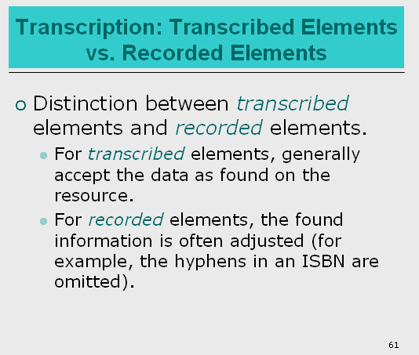

JZ: In RDA chapters 2-3, you will find the wording “transcribe … (an element) as it appears on the source of information” and this is an indication that the element is a transcribed element. For example. 2.3.1.4 “Recording Titles” says “Transcribe a title as it appears on the source of information” so we know “title proper” is a transcribed element. But if we look at 3.4.1.3 “Recording Extent,” it says “Record the extent of the resource by giving the number of units and an appropriate term for the type of carrier …” so we know “extent” is a recorded element. In RDA chapters 2-3 the instruction on “Recording …” follows the instruction on “Source of information” and the word “Recording” is different from “recorded element.” PCC RDA BIBCO Standard Record (BSR) Metadata Application Profile (http://www.loc.gov/aba/pcc/scs/documents/PCC-RDA-BSR.pdf ) is a good place to check if a bibliographic description element is a transcribed element or not.

CS: I haven’t found any place in RDA where the distinctions are made. I think that when RDA says “Recording [element name],“ it’s really saying “Follow these instructions to describe this part of the resource.” It is the umbrella verb used in RDA for the cataloger’s treatment of data. When describing/recording a resource, the cataloger:
- Transcribes some data directly with no changes (title proper)
- Adjusts some data (giving the number of units and type of carrier or giving the ISBN with no hyphens.
- Supplies some data (inferring the state name to add it to the city named in the place of publication).

6. Slide 76. At one of the first introductions to RDA I attended, an ALA preconference, the late Robert Ellett discussed a change in application of noun phrases. Since this comes up a lot in our belletristic cataloging (novels, poems, plays), I’ve been looking for further mention in other training sessions & haven’t found anything. In AACR2, rule 1.1.F12 considers the noun or noun phrase as an instance of other title information if it is indicative of the nature of the work.
Example: Characters from Dickens : dramatized adaptations / by Barry Campbell. [the rule continues] if the noun or noun phrase is indicative of the role(s) of the person(s) or body (bodies) named in the statement of responsibility rather than of the nature of the work, treat it as part of the statement of responsibility.
Example: Roman Britain / research and text by Colin Barham. [the rule continues] In case of doubt, treat the noun or noun phrase as part of the statement of responsibility.”
In RDA 2.4.1.8, Noun Phrases Occurring with a Statement of Responsibililty: “if a noun or noun phrase occurs with the statement of responsibility, treat the noun or noun phrase as part of the statement of responsibility. The RDA examples are the same as AACR2 1.1F12, but the “dramatized adaptations by Colin Barham” example is now used as an instance of a noun phrase entered in the statement of responsibility, while the AACR2 rule uses that example as an instance of the noun phrase as other title, i.e. as indicative of the nature of the work.

The old AACR2 formulation seems to have been moved to RDA 2.3.4. In 2.3.4.1. Scope: “Other title information may include any phrase appearing with the title proper that is indicative of the character, contents, etc., of the resource or the motives for, or the occasion of its production, publications, etc.” The RDA rule does not reference RDA 2.4.1.8. & it’s difficult to see the difference in use between the examples in 2.3.4.3. and 2.4.1.8.
Ellett’s take on the RDA application was to consider a noun or noun phrase grammatically linked to the creator, etc. as part of the statement of responsibility unless the noun or noun phrase was clearly presented as indicative of the content of the title proper. As I see it, in practice, entry of the noun or noun phrase in the statement of responsibility is generally limited to a form term that is not modified by a specific term indicative of the title proper content—assuming there is a grammatical link to the creator, etc. If there was not a grammatical link, even a noun or noun phrase not indicative of the content would have to be treated as an other title, or you would end up with a statement of responsibility in the form: [Title proper] / novel John Crowley.
So, some examples I used in training:
AACR2: 245 .. $a Otherwise : $b three novels / $c by John Crowley.
RDA: 245 … $a Otherwise / $c three novels by John Crowley.
An example where the noun or noun phrase is indicative of the content of the title proper:
RDA: 245 … $a Otherwise : $b three fantasy novels / $c by John Crowley.

Was Dr. Ellett on the right path in explaining the difference between the AACR2 application and the RDA application, and if so, is my interpretation consistent? Is a genre term sufficiently indicative of the content?

Module 1, slide 76
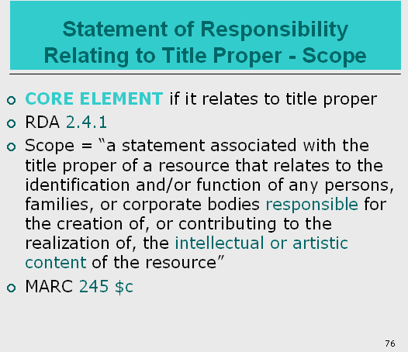

JZ: 2.3.4.1 Other title information is the information that appears in conjunction with, and is subordinate to, the title proper of a resource and may include phrases that is indicative of the character or contents of the resource. 2.4.1.8 Statement of responsibility relates to the identification and/or function of the entity responsible for the creation or contributing to the realization of the content of a resource. My guess is that RDA doesn’t want to make such a distinction and leaves room for cataloger’s judgment on when to consider the information is other title information and when is statement of responsibility. CS: Consider presentation on the resource?
PSD comment: Again, a conscious decision on the part of the JSC, this time intended to simplify the treatment of noun phrases occurring with a statement of responsibility, rather than treating some one way and some another way. From the change document cited earlier:
AACR2 1.1F12 details the conditions in which a noun phrase occurring in conjunction with a statement of responsibility is considered part of the statement of responsibility and when it is other title information. According to RDA 2.4.1.8 these phrases are always considered part of the statement of responsibility.
7. Slide 89. RDA 2.8.2. option. If the option to insert the larger jurisdiction in place of publication is chosen, is it correct that the abbreviations listed in Appendix B.11 should not be used? (based on Appendix B.4)
Module 1, slide 89
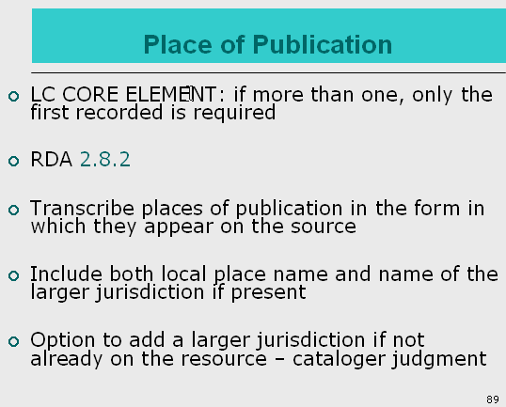

JZ: You are correct. Place of publication is a transcribed element. According to B.4 Transcribed elements “if supplying all or part of a transcribed element, generally do not abbreviate words.” So the abbreviations in B.11 should not be used.

PSD comment: RDA’s presumption is that you are supplying the larger jurisdiction that doesn’t appear on the resource, you found the information somewhere (i.e., there was some source for this information)—you would use the form on that source.

8. Slide 96 (instructor notes). RDA 2.8.1.4. Recording publisher name. If the distributor name is grammatically connected to the publisher name—e.g. Published and distributed by X publishing—transcribe the entire phrase in 264 _1 but don’t add a 264 _2?
Module 1, slide 96
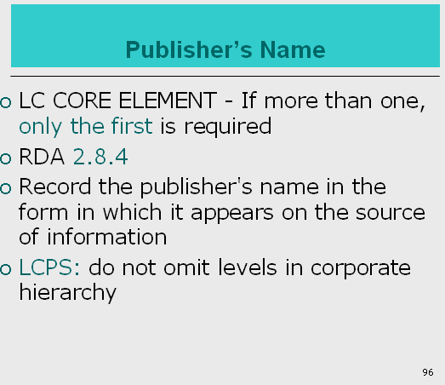

JZ: Yes. Because publisher’s name is a transcribed element and according to 2.8.1.4 transcribe publisher’s name in the form in which it appears on the source of information you would transcribe exactly “published and distributed by …” and would not give 264 _2 field.

9. Slides 137-138. When the source of title is not the title page, enter the title source for single part monographs in MARC 588 as well as multiparts?

Module 1, slide 137
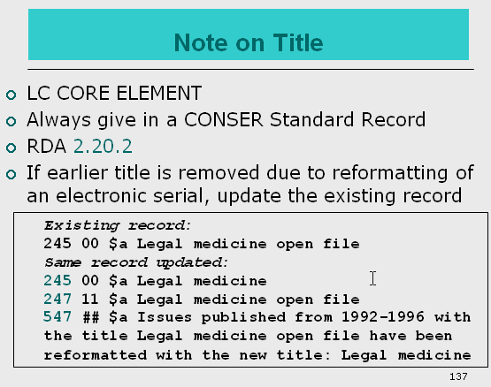
Module 1, slide 138
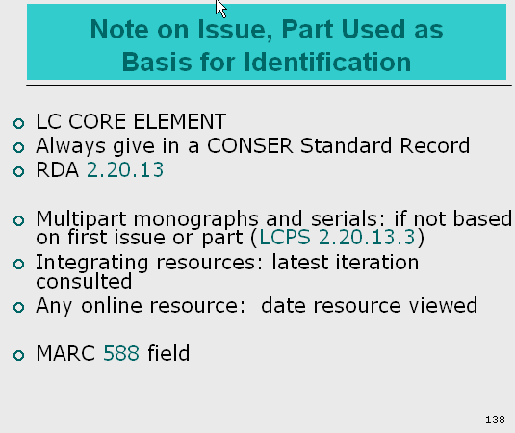

JZ: Slides 137-138 are about notes being used as core element on title or on issue, part used as the basis for identification. These notes apply to serials and multipart monographs. If you choose a title that is not from a title page for a single part monograph, follow 2.20.2 and make a note on the source from which the title proper is taken. Per RDA BSR document, for online resources, always supply a MARC Source of Description Note (588) combined with a source of title note (500).

From University of Pennsylvania

They are as follows:

A. RDA instruction 1.8.3 (Numbers Expressed as Words) indicates that numbers expressed as words should be substituted with numerals. Is this also true for numbers expressed as letters, as is the case for Hebrew/Arabic/Persian letters (each of which has a corresponding numerical value)?
JZ: For Hebrew/Arabic/Persian letters (each of which has a corresponding numerical value), we should follow 1.8.2 Form of numerals. At the moment, LC is adopting RDA’s 1st alternative to record the form as it appeared on the source. There could be changes in the future in this area. Other non-Latin languages also share similar situation.
B. We are an ECIP program participant. We'd like to check that our reading of the instructions is correct with regard to transcribing elements.
(1) Sub elements in the Publication statement, Distribution statement, and Manufacture statement can be taken from the data view when cataloging CIPs at the galley stage (LCPS 2.8.2.2) but if a Series statement only appears in the data view when cataloging CIPS at the galley stage, we should not transcribe it at all (LCPS 2.12.1.2).
(2) What about other elements?
JZ: I can’t think of others.
C. We would like more guidance about when to transcribe an element and when to record it. We are aware of the R-1 document that lists this information for the variable fields.
(1) Can we assume this list is accurate and complete?
(2) If not, is there a comprehensive list anywhere?
(3) What about the variable fields?
(4) For example: RDA instruction 2.15.2.4 (Recording Identifiers for Manifestations) -- the instructions say to record (not transcribe) such identifiers; is this also true for qualifiers of an ISBN (like: "paperback")? Appendix B (Abbreviations) instruction B.5.11 reads "Generally do not abbreviate words in elements other than those covered under B.5.1 and B.5.3–B.5.9. Generally do not abbreviate words recorded as part of details of an element," and instruction B.4 reads "For transcribed elements, use only those abbreviations found in the sources of information for the element." So should we record paperback as is, and not abbreviate it to pbk., correct?
Answer:
From Phong: I have raised this myself before. The response was that since the 020 does not encapsulate a transcribed element, it doesn't really matter if we render as "paperback" or "pbk.". But I don't really understand the reasoning for this.

JZ: I think the bigger message here is that do not abbreviate words in transcribed elements. In other words, if it is a recorded elements such as ISBN (identifier for manifestation) record it according to the prescribed display format (omit hyphen in this case) and record a qualifier if needed. It is cataloger’s choice to choose the form it is used in the qualifier. PCC RDA BIBCO Standard Record (BSR) Metadata Application Profile (http://www.loc.gov/aba/pcc/scs/documents/PCC-RDA-BSR.pdf ) is a good place to check if a bibliographic description element is a transcribed element or not.

D. We would like more guidance (especially examples) for instruction 2.3.3.3 (Recording Parallel Title Proper). Can you address the following separate scenarios:
(1) Foreign title proper : rest of Foreign title info / Foreign creator || English title proper : rest of English title into / English creator.
Under AACR2 this would be recorded as: All of the Foreign data = All of the English data; under RDA are we only including the parallel title proper in the 245 field?
Regarding D: the parallel title proper is LC-PCC core according to the PS for 2.3.3.3. The parallel SOR relating to the title proper (2.4.3), however, is not core. So, the 2 acceptable scenarios that would be:
1. title proper : other title info / SOR = parallel title proper : parallel title info / parallel SOR.
2. title proper : other title info = parallel title proper : parallel title info / SOR.
JZ: In terms of MARC format and encoding, I don’t think there has been any change under RDA on recording parallel title information.

(2) UPenn sent a 3-page PDF for this item, and we’ll share it during the webinar) A work that is translated into three languages, Hindi (Devanagari script), Punjabi (Gurmukhi script) and Sanskrit (Devanagari script). The original work is in Persian (Perso-Arabic script) with transliteration in Devanagari, but it also has a completely different name in Sanskrit. All four titles appear on the title page. There are two parallel titles, and three languages (scripts) in which the title is rendered from the Persian.
Carolyn’s attempt to list the situation-- U Penn says the t.p. has…
Persian title (Perso-Arabic script with transliteration in Devangari)
Persian title in Hindi (Devanagari script)
Persian title in Punjabi (Gurmukhi script)
Sanskrit variant title (Devanagari script)

…and Carolyn sees English on it, too:

A Saint’s reply to an Emperor
The Classic Sikh Literature
In four languages

Original Text in Persian Verse
Transliteration and Translation in HINDI
And verse to verse translation
In
SANSKRIT & ENGLISH
(DUAL LANGUAGE SYSTEM)

Answer:
Regarding the doozy example: 2.3.3.3 does not put a limit (RDA does not like limits!) on how many parallel titles we should record. However, we do have the following passage from 0.6.1 as a way out(!):
As a minimum, a resource description for a work, expression, manifestation, or item should include all the core elements that are applicable and readily ascertainable.
"Ready ascertainable" is the key phrase here. If, for example, I can deal with 1 (or 2 even) of the parallel titles, but not all of them, I have been guided by my RDA gurus to apply this passage from 0.6.1 to do what I can and move on. At any rate, that particular passage from 0.6.1 would probably be applied differently by different institutions depending on their resources.

Suggested 245:
245 10 ‡a Zafaranāmā = ‡b Ẓafarnāmah = Vijayapatram = Zafarnama / ‡c Gurū Govinda Siṃha praṇīta ; anuvādaka Ācārya Dharmendranātha.

JZ: RDA 2.3.3.3 Recording Parallel Titles - If there is more than one parallel title proper, record the titles in the order indicated by the sequence, layout, or typography of the titles on the source or sources of information.

From UT Austin

- Please verify that we do not convert dates of publication to Arabic numbers if they appear on the resource as Roman numerals.

Answer: Yes. Instructions in 1.8.1 apply to publication dates as well as other types of numbering and chronology. The LC-PCC PS 1.8.2 gives LC policy on the first alternative to record numbers as they appear. Relabeling of this PS to read LC/PCC practice was recommended by the PCC Policy Statements TG and approved by PoCo- the relabeling process has not caught up with this, but best to consider this LC/PCC practice.

- If we are supplying a larger jurisdiction (e.g.: state name) in the place of publication, do we need to abbreviate the state name since the state names are included in Appendix B Abbreviations? For instance, if on the piece we are cataloging it says “Paris” and we know it is Paris, Texas (but Texas does not appear on the piece), do we put in the 264 field “Paris [Tex.]” or “Paris [Texas]”?

Answer: Generally prefer the spelled out form in line with general RDA preferences for spelling out supplied elements.

JZ: Also covered in Yale’s questions #7.

- In the 588 field, or other recorded fields, do we need to abbreviate the months? For instance, if we have in the 588 field a viewed on date for an online resource, do we say “viewed on Jan. 23, 2013” or “viewed on January 23, 2013”?

Answer: Since this is a note and not strictly transcribed data, it is ok to follow the examples in RDA 2.20.13.5 and use abbreviations shown there, e.g. “viewed on Oct. 21, 1999”

- Does LC-PCC still follow ISBD punctuation rules? If so, can we assume we still input double periods as a result of following ISBD?
(For instance, if the edition statement reads “Second ed.” on the piece, would the 250 field be “Second ed..” with two periods? What about the 300 field? If we are ending the field with 4 ¾ in. for the dimensions of a CD-ROM, would we put “4 ¾ in..” if it is followed by a 490 field?)

Answer: Yes our implementation of RDA in MARC 21 is following ISBD presentation outlined in Appendix D.1, but with some modifications. Please see specific instructions in the first LC-PCC PS 1.7.1 “Punctuation at the End of MARC Fields 245, 246-247, 250, 264, 300, 310/321, 362, 490”
- Fields 245, 250. If either field 245 or 250 does not end in a period, add one.
3.) Field 300. Field 300 may end in no punctuation, may end in a right parenthesis when the last element of the field is a parenthetical qualifier, or may end in a period when the last element is an abbreviation. When a record has a 490 field, insure that field 300 ends in a period. So you would have 4 ¾ in. whether or not it is followed by a 490 field.

- Similarly, if the 300 field ends with a right parenthesis, and it is followed by a 490 field, would we put in “(4 ¾ in.).” ending the field with a period?

Answer: Because the instruction requires 300 ends in a period when the record has 490 field, when the 300 field ends with a right parenthesis, we should add a period after the parenthesis:
300 … (4 ¾ in.).
See #4 answer.

