From Harvard U

- How should one record the unnumbered first page in a bibliography? It seems ridiculous to put “Includes bibliographical references (1 unnumbered page, pages 265-270)” but is this what is expected? Instead we numbered the page and left it unbracketed because the information is in a note field and the source for notes is from anywhere. Therefore we decided to enter this as “Includes bibliographical references (pages 264-270).” Is this wrong?

Answer: This is correct. Admittedly, this is only covered glancingly in the material for Module 1. Slide 60 directs you to follow LC-PCC PS 1.7.1, and slide 61 emphasizes that for recorded information (e.g., pagination in a note) data are often adjusted, rather than transcribed as-is. In LCPS 1.7.1 -- that long general LCPS on punctuation -- see point 3 under "Punctuation in Notes": "Do not use square brackets in notes except when they are used in quoted data."

Module 1, slide 60
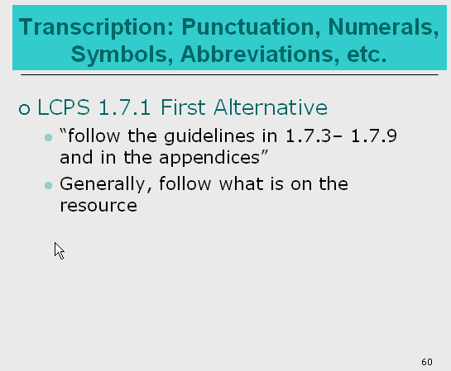

Module 1, slide 61
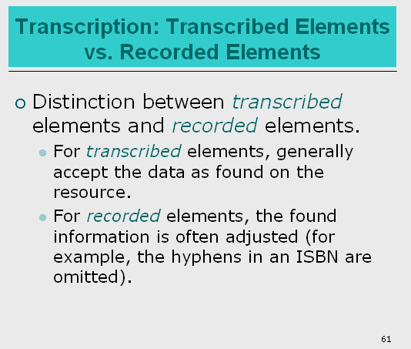

LC-PCC PS 1.7.1 example about no brackets in Notes:



2. In the past we would put the print ISBN and the ebook ISBN on the print bibliographic record. However, since the ebook is a different manifestation, in RDA should we only put the print ISBN on the bibliographic record for the print manifestation? Of course the ebook ISBN is on the t.p. verso of the print in most cases, but should we just ignore it when recording ISBNs on the print manifestation record? A follow up question can be, should we remove it if we see an ebook ISBN on an RDA print manifestation bibliographic record?

Answer: According to: LC-PCC PS for 2.15.1.7 on QUALIFICATION
LC practice: When transcribing multiple ISBNs, transcribe first the number that is applicable to the manifestation being described; transcribe other numbers in the order presented, with appropriate qualification to distinguish.
Record ISBNs in $z (Canceled/invalid) of MARC field 020 if they clearly represent a different manifestation from the resource being cataloged and would require a separate record (e.g., an ISBN for the large print version, e-book, or teacher’s manual on the record for a regular trade publication). If separate records would not be made (e.g., most cases where ISBNs are given for both the hardback and paperback simultaneously), or in cases of doubt, record the ISBNs in $a (International Standard Book Number) of MARC field 020.

3. And my next question is in your “special topics” document on compilations, on slide 14, it instructs us to enter a 505 “Give MARC 505 contents note unless contents indicated in another part of the of the description (e.g., in MARC 245 $a because no collective title present) or unless burdensome” I have the following example:

010 2010677951
040 OHX ǂb eng ǂe rda ǂc OHX ǂd GWDNB ǂd NLM ǂd EUW ǂd OCLCQ ǂd DLC ǂd OCLCO ǂd TOZ …
24500Ärztliches Ethos im Kontext : ǂb historische, phänomenologische und didaktische Analysen / ǂc Walter Bruchhausen, Hans-Georg Hofer (Hg.).
264 1[Göttingen] : ǂb V & R unipress ; ǂa [Bonn] : ǂb Bonn University Press, ǂc [2010]
300 164 pages ; ǂc 25 cm.
336 text ǂ2 rdacontent
337 unmediated ǂ2 rdamedia
338 volume ǂ2 rdacarrier
4901 Medizin und Kulturwissenschaft ; ǂv Bd. 6
500 Includes bibliographical references and indexes.
650 0Medical ethics.
650 0Medical ethics ǂz Germany ǂx History.
65012Ethics, Medical.
65007Medizinische Ethik. ǂ2 swd
6530 Medical ethics
7001 Bruchhausen, Walter, ǂe editor of compilation.
7001 Hofer, Hans-Georg, ǂe editor of compilation.
830 0Medizin und Kulturwissenschaft ; ǂv Bd. 6.
85641ǂu http://d-nb.info/1004069669/04 ǂ3 Inhaltsverzeichnis
938 Otto Harrassowitz ǂb HARR ǂn har105013975
0291 HEBIS ǂb 230323332
0291 NLM ǂb 101551094

In this case there is a link to the pdf of the entire table of contents in the 856. Do we still need to retype the entire table of contents into a 505? I understand that your guidelines state that if the contents are already “indicated in another part of the description” we do not need to enter a 505, but the 856 is not part of the “description” if you are using that word as a cataloger would mean it. It just seems out of sync with RDA and linked data principles to repeat this information when we have a readily available link to the information. However, I would like to know what LC will be doing in these cases.

Complications & Collaborations, slide 14, partial:

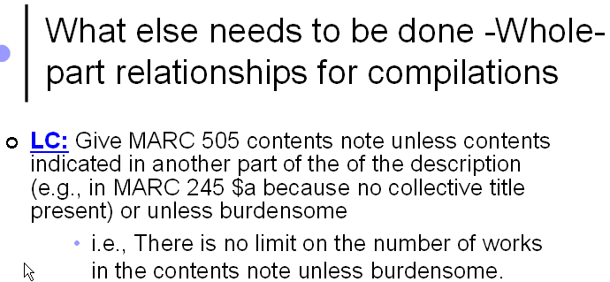

Answer: The instruction on providing 505 contents note is given in the context of related work under 25.1. Related work is an LC CORE element and instruction on treating the related work is to provide a contents note and an analytical authorized access point for the predominant or first work in the compilation. This also includes part of a whole work situation such as the compilation of different chapters of a work. There is an exception to apply the above instruction and that is when you have publication of anthologies of poetry, hymnals, conference proceedings, journals, collections of interviews or letters, and similar resources. This is where cataloger’s judgment comes into play. Should we add 505 contents note to any compilation, such as a compilation of articles on the history of German medical ethics? If you think it is important to provide the structured contents note meaning the content you provide in the record is searchable by users then give it. Otherwise, it is OK not to give the contents note. The 856 field provides helpful electronic location to the table of contents. As you noted, this is info. for the source not the description of the content and the information provided in these two fields functions differently though for the same purpose.

The slide, prepared by LC, gives the LC practice. The RDA BSR for the element “Collective titles and titles of individual contents” has a plus sign, + following it, indicating that it is a PCC Core element, and cites 25.1.

4. A question from a colleague concerning RDA and the date of publication. This is an LC RDA record created on Dec. 27th, 2012.
010 2012429473
040 DLC ǂe rda ǂb eng ǂc DLC
020 9780957166004 (Cloth)
020 0957166001 (Cloth)
042 pcc
043 e-uk---
05000ND196.P7 ǂb A42 2012
08200759.2 ǂ2 23
090 ǂb
049 TOZZ
24500ABNA : ǂb the Association of British Naïve Artists / ǂc editors, Judy Joel and Daphne Stephenson.
24618The Association of British Naïve Artists
250 First edition.
264 1Mousehole, Cornwall : ǂb Colourhouse, ǂc January 2012.
300 108 pages : ǂb color illustrations ; ǂc 22 cm
336 text ǂ2 rdacontent
337 unmediated ǂ2 rdamedia
338 volume ǂ2 rdacarrier
500 Includes index. …
7001 Joel, Judy ǂe editor.
7001 Stephenson, Daphne ǂe editor.
7102 Association of British Naïve Artists.

The date of publication is “January 2012.”
Our question is, should we record the month in the 264 |c? Or should this have been recorded as “[2012]?” It would then be cataloguer’s judgment to add a 500 note with “January 2012.”

I think it depends on whether you can consider the month/year as a “publication date” or if you are inferring a publication date. Since this happens fairly often, we would like some guideline from LC as to how to proceed when “month/year” is listed on our manifestations.

In RDA 2.8.6.3 there is an example for “May 2000.” Since the month/year as publication date is in RDA, I will assume that we give month/year if that is what appears on our manifestation from now on. Please let me know if this is incorrect.

Answer: Similar questions came up during our last month’s webinar. I agree we probably should confirm the practice with PSD on whether to add the month in the 264 field when it’s available in the resource. Under RDA BSR document, we know the date of publication is a recorded element so we can make adjustment if needed. Since RDA 2.8.6.3 does provide an example of including the month in recording date of publication and there is no specific LC-PCC PS in the area, I think we can provide the month if we want to but can also omit it. Between including the month in the 264 field option and the option of giving year only and then add a 500 note about the month, I probably would choose the first option for the simplicity. I would definitely not use [2012] as it is not an inferred year.

PSD: need to confirm if there is best practice or both options are acceptable on including month for the date of publication in 264 field.

From Cornell University

1. RDA’s example of an authorized access point which uses content type as an addition to break a conflict is:
Brunhoff, Jean de, 1899–1937. Babar en famille. English. Spoken word
Resource described: Babar and his children. An audio recording of an English translation of the children’s story

Under LCPS 6.27.3, since this is not a music resource or a sacred scripture, and the translation aspect is covered in the legitimate |l English, is this RDA example a step further than LC/PCC cataloging would normally go? Content type as an addition “seldom comes into play,” according to page 3 of the manual—but audiobooks are common, so we’re deducing that we won’t be breaking out audiobooks onto their own expression record, relying instead on the 336 and 264. Could you give an example of a situation, real or imaginary, where content type is correctly used at LC as an addition to an authorized access point for an expression?

Answer: According to DCM Z1 instruction and the PCC Task Group on Expressions’ recommendations, content type cannot be used as an addition to an access point for the expression to differentiate between two expressions of different content types. However, PCC practice again based on the Task Group’s recommendations allows for adding other expression type to differentiate between different expressions, such as date of expressions, language of expressions, translator, contributor, etc.

Report of the PCC Access Points for Expressions Task Group http://www.loc.gov/aba/pcc/rda/RDA%20Task%20groups%20and%20charges/PCCExpressionTGFinalReport.docx

2. Here at Cornell, we’re rather attached to the “Cornell Yeats,” a big series on n 84749954. The authorized access point is Yeats, W. B. |q (William Butler), |d 1865-1939. |t Works. |f 1982. Since it’s a series and neither LC nor Cornell traces series (although we break the rule in this particular case), we can live with Module 3 telling us not to use |f following Works. (RDA “Works. |f” examples at 6.27.3 sure are misleading!) Question: what is going to happen to that series authority record? Could we show a proprietary interest and update the series authority record to RDA? More generally, is LCPS 6.27.3 telling us to leave big sets of famous peoples’ Works (like presidential papers) undifferentiated? Or we allowed to make an addition to break a conflict?

Answer: First let’s say that the example on “Works. $f date” example in 6.27.3 is not wrong. RDA allows differentiating characteristics or expression attributes to be added either as separate elements or as part of the authorized access point to differentiate between different expressions. But the LC PCC PS went on further to identify expressions only in the four areas included in 6.27.3, and conventional collective titles such as works is not included there. So as a LC-PCC practice we do not add date of expression to “Works” anymore. A couple of points to note here with regard to the question. Remember, the conventional collective titles are rule-based imposition to the complete works of a creator is considered the same work so there is no conflict when we refer to complete works regardless of different publication dates. This decision was made by LC on choosing not to differentiate the works for the sake of cataloging efficiency – somewhere we have to draw a line and this is one of them in my understanding. Can libraries have the option of adding date in your case? We will bring your comments to PSD.

PSD: need to confirm on the option of differentiating the big set of works.

3. This question has to do with slide 66 – “What Constitutes a New Work?”

Module 3, Slide 66


The following situation comes up from time to time:

An author creates a canonical work that goes through many editions.
After years of successive editions, the original author takes on a co-author(s), but the scope of the resource is substantially the same as the original.
Eventually, the original author dies or is otherwise out of the picture, but is sometimes still mentioned on the title page, perhaps even as part of the title (e.g., Prosser, Wade, and Schwartz's cases and materials on torts; 9th ed. was published in 1994, but Prosser died in 1972).

Could you please go over for us if and at what point the resource becomes a new work?

Answer: In the case of different editions, slide 66 gives two criteria to decide if there is a new work: 1) has the resource substantially changed the nature and content of that work, and 2) is the resource considered as the work of the different author?

If the earlier edition lists one creator, and the next edition lists the original creator and an additional creator, it is still important to look at the nature and content of the work.
However, if in fact the original author is no longer considered as one of the people responsible for the creation of the work, this indicates that the nature and content of the work has been altered considerably and we would consider the subsequent work as a new work (6.27.1.5).

Examples suggested by George Prager, based on his discussions with LChelp4rda@loc.gov:

Two good examples in RDA 26.1.1.3 on Referencing Related Expressions:

1. Revision of: Roget, Peter Mark, 1779–1869. Thesaurus of English words and phrases
Resource described: Roget's Thesaurus of English words and phrases. — New edition / completely revised and modernized by Robert A. Dutch.

2. Revision of: Biology of fishes / Carl E. Bond. — Second edition. — Fort Worth : Saunders College Publishing, [1996]
Resource described: Bond's Biology of fishes / Michael Barton. — Third edition — Belmont, CA : Thomson, [2007]

Found the LC database, January 2013, all presumably AACR2:

77084665 Ldr/18 = i (but no $e rda)
100 Bond, Carl E.
245 Biology of fishes /$c Carl E. Bond
300 Philadelphia : ‡b W. B. Saunders Co., ‡c 1979.

95067414 Ldr/18 = a
100 Bond, Carl E.
245 Biology of fishes / ‡c Carl E. Bond.
250 2nd ed.
300 Fort Worth : ‡b Saunders College Pub., ‡c c1996.

2005932707 Ldr/18 = a
100 Barton, Michael.
24510 Bond's biology of fishes / ‡c Michael Barton.
24630 Biology of fishes
250 3rd ed.
300 Belmont, CA : ‡b Thomson, ‡c c2007.
500 Rev. ed. of: Biology of fishes / Carl Bond. 2nd ed. 1996.
7001 Bond, Carl E. ‡t Biology of fishes.

Both in AACR2 would not be entered under the name of the original creator, but in RDA are considered expressions of the original work, and are still entered under original creator.

Two useful points about this, especially the 2nd example:
- Just because Bond's name is in SOR does not make him the 1XX.
- And PSD told me that regardless of whether Bond's name wasn't in title proper, we would still need to consider whether the nature and the content of the work has substantially changed.

Both these conditions need to be met for the new ed. to be considered a new work.

Additionally, as PSD pointed out, when considering RDA 6.27.1.5, the general principle of "don't catalog by example" is very important here. Each bibliographic situation must be considered individually, and you have to look at the content of the resource at hand in comparison to the content of the earlier version.

