Questions from Northwestern:

1. Module 3, slide 26 ("Mail carrier" example): We have been told that 1XX/240 or 1XX/245 (title proper portion) or 130 is the authorized access point for the work/expression. Why is the first 700 field in this record? It duplicates *exactly* the 100/245 (title proper portion) combination in the record.

Module 3, slide 26
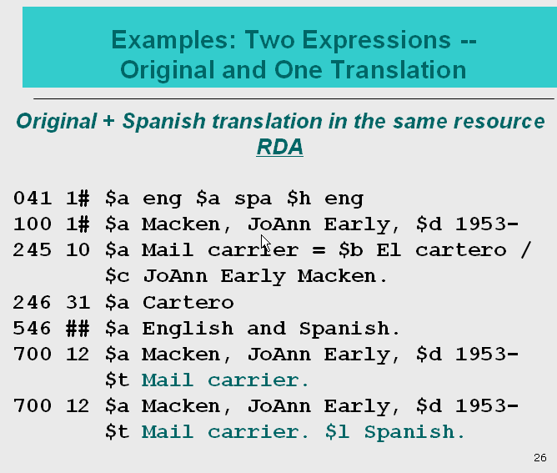

Answer: The 700 is required by LC-PCC PS for 26.1 (second
paragraph). The first 700 is the analytical access point for the original
expression, not the work. [The 100/245 serves as the access point for the
work.]

The 100/245 describes both the English original and the Spanish translation, while the first 700 provides access only to the original expression (see LC-PCC PS 6.27.3, where this example comes from). It is incomplete to look at and parse only a portion of the 245.
(And in fact this is exactly why we no longer do what we would have done according to AACR2 in such a case -- which was to provide a 240 with the now-prohibited “Spanish & English”). We can‘t put multiple languages in a single $l, and to record only one of them (i.e., the original) would not be correctly ‘identifying the expression’; it would only identify one of the two expressions. The separate a.a.p.’s are the way of providing access to each (here, ‘both’) expression.)

2. Module 3, slide 56 (Attributes of Expressions--Language of the Content): LC-PCC PS 7.12 says this is "Core element for LC". Yet the slide says to "record if considered important". If it's Core, wouldn't recording be mandatory if applicable? (Otherwise it sounds like cataloger judgment.)

Module 3, slide 56
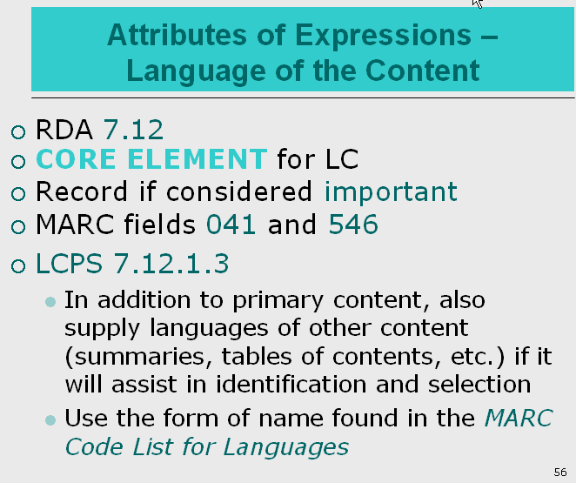

Answer: This is admittedly awkward. Language of the content is indeed core, and that can always be satisfied through use of the menu in the 008. THAT is mandatory. Where it becomes a question of ‘if considered important’ is in cases where an additional language expression attribute needs to be described -- such as by using a 546 and/or 041. Even in the case of a single language expression, a cataloger may record a 546 for “In “Esperanto” or whatever, ‘if it is considered important,’ in their judgment.

I think that the “Record if considered important” on the slide refers to LC-PCC PS 7.12.1.3 which says “In addition to recording the language of the primary content, also supply the languages of other content (summaries, tables of contents, etc.) if it will assist identification and selection."

3. Module 3, slide 58 (Attributes of Expressions--Supplementary Content): LC-PCC PS 7.16 says this is "Core element for LC". Yet the slide says to "record if considered important". If it's Core, wouldn't recording be mandatory if applicable? (Otherwise it sounds like cataloger judgment.)

Module 3, slide 58
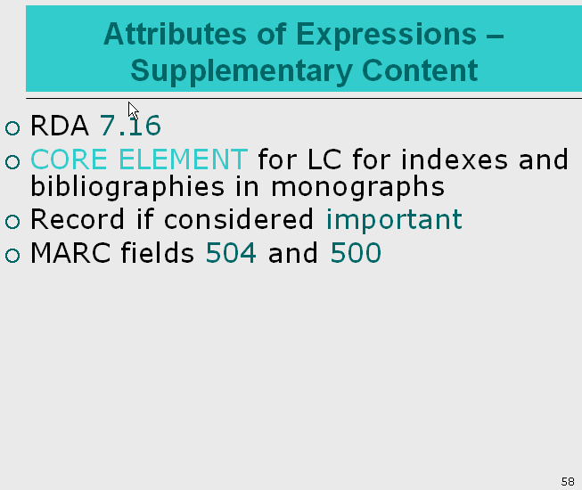

Answer: This is like question 2 above, and in retrospect the 2nd and 3rd bullets should be reversed. The RDA instruction includes the ‘if important’ clause. The LC-PCC PS does not refute this, but rather goes further, by clearly stating that, for a certain scope of resources (monographs), LC routinely considers bibliographies and indexes to be important (in effect, relieving the cataloger of the judgment as to whether they are important enough to be recorded.

I agree and think that the “Record if considered important” refers to LC-PCC PS 7.16.1.3 which talks about recording other types of supplemental content, appendices, erata slips, etc.

4. Slides 16 (RDA 6.9) and 30 (RDA 6.12) talk about additions to access points for expressions, and their being core elements when needed to differentiate. There seems to be a contradiction with slide 9, which says that expressions will only be differentiated in the cases of music resources, sacred scriptures, and translations and language editions. How does an example like "Spoken word" (slide 16) happen then?

Module 3, slide 16
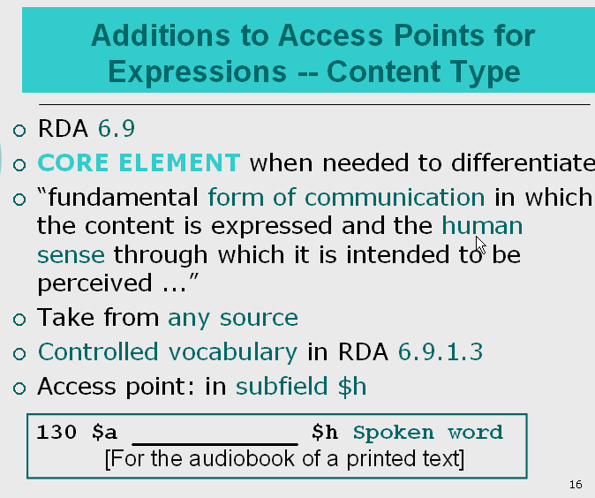

Module 3, slide 30
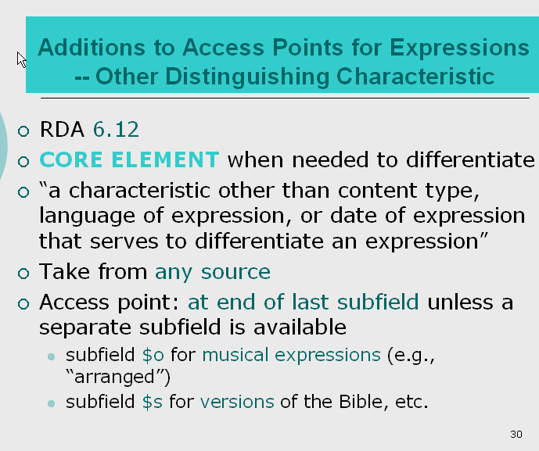
Module 3, slide 9
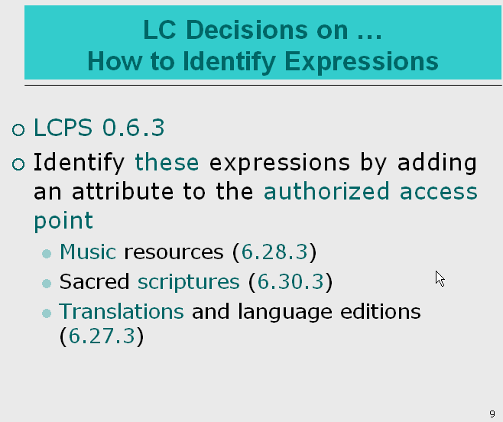

Answer: Indeed this example is inappropriate because it is not the material that falls into one of the four situations in terms of identifying expressions. Further, per DCM Z1, content type in $h is not allowed to be used in the authorized access point. However, content type is recorded in the bibliographic record allowing for differentiation. The policy in this area was changed since the training material was created. This example is incorrect and should be removed according to the current policy.

5. The rules about compilations of the works of one person require conventional collective titles yielding access points like:

Rilke, Rainer Maria. Works
Rilke, Rainer Maria. Poems
Rilke, Rainer Maria. Poems. Selections

These collective titles and "Selections" are all considered work level attributes, and LCPS 6.27.1.9 says that we must resolve conflicts between authorized access points for works, but of course these AAPs will apply to multiple works. Do we have to resolve these conflicts, and if so, how?

Answer: I would suggest that is related to (not exactly the same, but the same general institutional policy principle) as what is covered on slide 11. There, it is stated that LC will not differentiate ‘a step further’ and add, e.g., the name of the translator of the particular French translation. In effect, we want the name-title NAR to be ‘applicable’ for all manifestations of a French translation of Hamlet (regardless of the manifestation title -- hence, as we have historically done, with multiple 400at fields to the same 100at). Basically a workflow consideration. And, of course, that LC decision does not necessarily require adoption by other institutions.

Module 3, slide 11
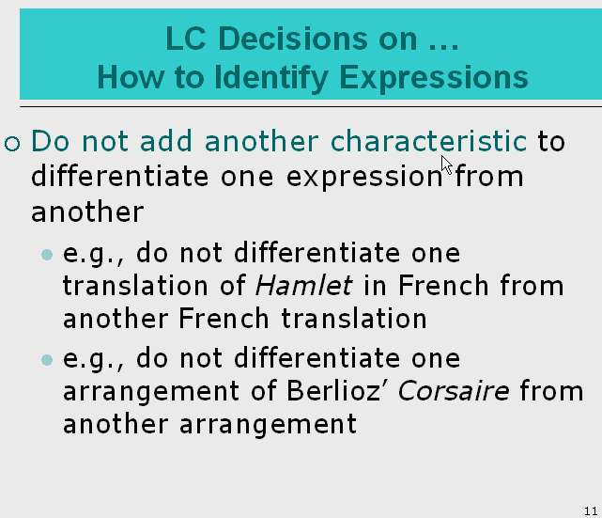

The use of conventional collective title is a rule-based cataloging decision for a preferred title for a compilation of works. Thus the compilation of the works of a creator are considered the same work and are not in conflict. For collective titles and “Selections,” it is true that the selections are not always the same, but LC has chosen not to differentiate these for time saving purpose.

Question from the University of Oregon:
Additions to access points for expressions -- Date of Expression (slide 21):
We are wondering if there are cases in which we should add the date of expression to the access point for a translation. Slide 21 is a little confusing; it says that Date of Expression is NOT a core element for LC and is used "only for music, sacred scripture, translations". According to slide 11 and the LC-PCC PS for 6.27.3, we do not add another characteristic to differentiate, for example, one French translation from another.
We think the LC-PCC PS 6.27.3 is clear that date of expression should not be added for a translation, and the language in the slide "only for music, sacred scripture, translations" refers to adding an expression attribute in general, not specifically date of expression. Just wanted to check our understanding.

Module 3, slide 21
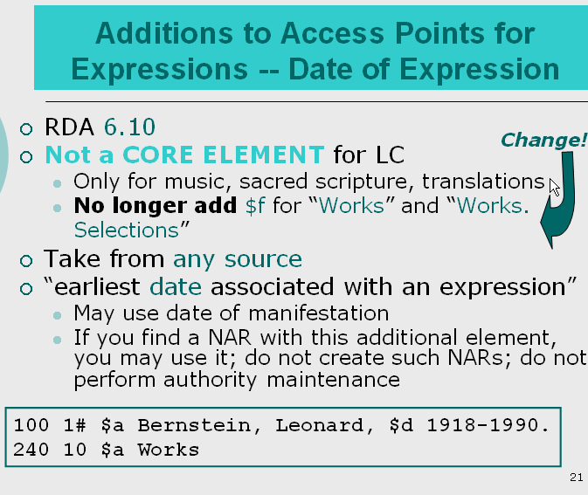

Answer: LC-PCC PS 6.27.3 represents LC’s decision not to make additions to further differentiate language expressions beyond the language attribute. The LC-PCC PS mentions that PCC’s decisions about further differentiating an authorized access point for expressions are pending. The Report of the PCC Access Points for Expressions Task Group refers to LC PCC PS 6.27.3 and recommends generally following LC’s policy, but allows some PCC cataloger flexibility in making a decision about this that LC would not require.

Question raised at the webinar from Arizona State University:

Module 3 Exercise 6 about 130 fields – some end with final stop and some do not. Which way is correct?

Answer: According to LC-PCC PS 1.7.1 General Guidelines on Transcription, for bibliographic records, generally end authorized access points with either a period or other ending mark of punctuation (a period, closing parenthesis, closing bracket, quotation mark, question mark, exclamation mark, and hyphen., with the exception of 240 field.

Question raised at the webinar from University of North Carolina:

I have two or more consecutively numbered parts, with both part numbers and the specific titles of each part, what would be the preferred title?

Answer: If the parts are known by their own titles and have numbering associated with them, they are identified by the part titles not the general designation in the authorized access point. Under LC practice for the alternative at 6.2.2.9.2, the preferred title for the two parts is “Selections.” So the authorized access point here would be: “preferred title for the work. Selections.”

If I only have a map, what should I use in the 300 illustrations? Under AACR2 I can specify “map.”

Answer: RDA 7.15.1.3 Alternative says to record the type of illustrative content in place of or in addition to the term illustration or illustrations, if it is considered to be important for identification, e.g., maps. There is an LC-PCC PS on LC practice 7.15.1.3 that says generally do not record the type of illustrative content in place of or in addition to the term "illustration" or "illustrations." But this instruction is labeled only for LC practice.

