**BRBL ArchivesSpace Assessment Records**

Create an ArchivesSpace assessment record when:

* An accession is created and assigned the Processing Status value “Pending Processing “
* A resource is completed for a newly processed collection
* An addition is added to an existing resource
* A significant processing activity is undertaken on a collection (i.e. a baselined collection receives full processing)

**Assessments for Pending Processing Accessions**

1. In the accession record, create an assessment record by go selecting “More” and “Create Assessment”
2. In the “Existing Description” section, select appropriate fields, which will frequently include “Box/Container List,” “Collection/Control File,” and “Deed of Gift” (which includes purchase agreements)
3. Add existing description notes to convey the quality, accuracy, re-usabilty, and comprehensiveness of the existing description.
4. Add your name in the “Surveyed By” field
5. Add today’s date in the “Survey Begin Date” field

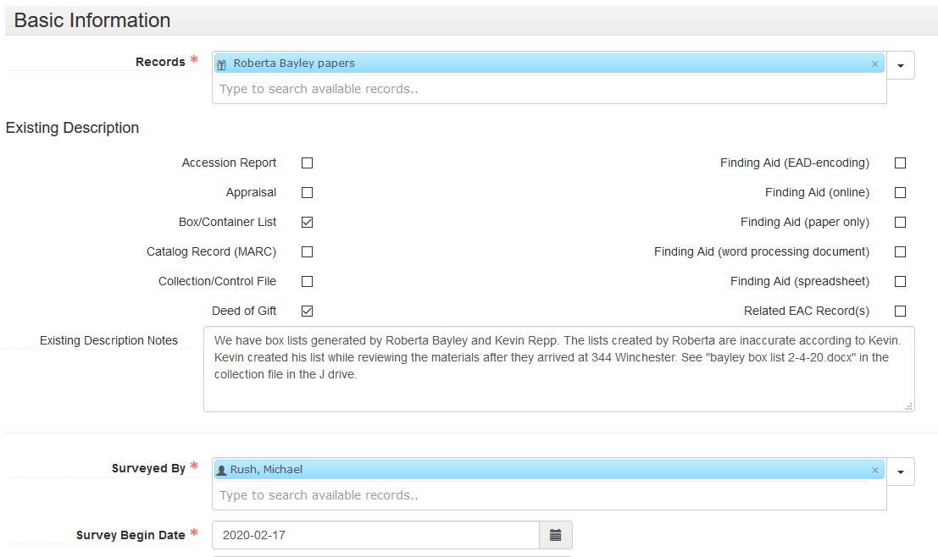

1. LEAVE BLANK/DO NOT CHECK the following fields
   * Survey Completed Date
   * Time it took to Complete Survey
   * Extent Surveyed
   * Review Required?
   * Who Needs to Review
   * Review Note
   * Scope of Assessment
   * Inactive?
2. If materials are deemed sensitive, check “Sensitive Material?”
   * If Sensitive Material is checked, note the nature of the sensitive materials in the General Assessment Note.
   * Examples of sensitive materials include but are not limited to the following:
     + Sexually-explicit material
     + Racially and culturally insensitive materials
     + Drug paraphernalia
     + Personal and confidential information (medical records, financial records, student records, Social Security Numbers)
     + Perishable/organic matter
     + Human remains (hair, teeth, ashes)
3. In the “Purpose of Assessment” field, input “Initial review”
4. Use the “General Assessment Note” field as needed, including noting sensitive materials or other processing challenges. Note significant factors that will make processing easier or more challenging.
5. Assign ratings and add notes as needed
6. DO NOT assign a rating for “Reformatting Readiness” (leave at “No Rating”)
7. Select material types/formats
8. Fill in “Special Format Note” as needed
9. LEAVE BLANK the following fields
   * Exhibition Value Note
   * Monetary Value
   * Monetary Value Note
10. Select applicable Conservation Issues
11. Fill in “Conservation Note” as needed

**Assessments for Resources**

1. In the resource record, create an assessment record by go selecting “More” and “Create Assessment”
2. In the “Existing Description” section, select “Finding Aid (EAD-encoding)” and “Catalog Record (MARC)”

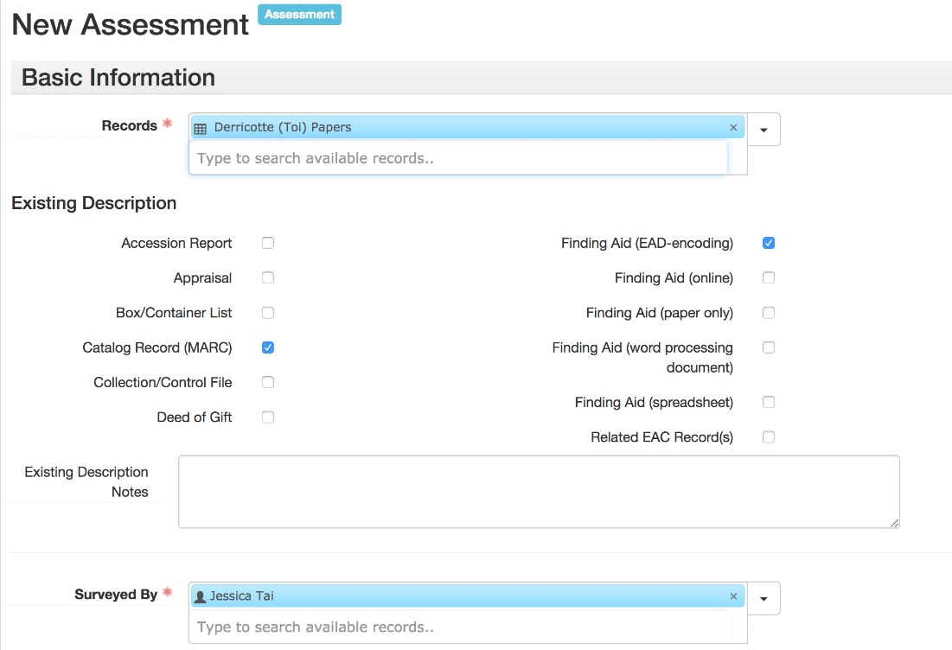

1. Add existing description notes if additional descriptions are available in addition to the ASpace resource and catalog record.
2. Add your name in the “Surveyed By” field
3. Add today’s date in the “Survey Begin Date” field
4. LEAVE BLANK/DO NOT CHECK the following fields
   1. Survey Completed Date
   2. Time it took to Complete Survey
   3. Extent Surveyed
   4. Review Required?
   5. Who Needs to Review
   6. Review Note
   7. Scope of Assessment
   8. Inactive?
5. If materials are deemed sensitive, check “Sensitive Material?”
   1. If Sensitive Material is checked, note the nature of the sensitive materials in the General Assessment Note.
   2. Examples of sensitive materials include but are not limited to the following:
      1. Sexually-explicit material
      2. Racially and culturally insensitive materials
      3. Drug paraphernalia
      4. Personal and confidential information (medical records, financial records, student records, Social Security Numbers)
      5. Perishable/organic matter
      6. Human remains (hair, teeth, ashes)
6. In the “Purpose of Assessment” field, input “Post-processing”
7. Use the “General Assessment Note” field as needed, including noting sensitive materials or other processing challenges. Note significant factors that will make subsequent processing easier or more challenging.
8. Assign ratings and add notes as needed
9. DO NOT assign a rating for “Reformatting Readiness” (leave at “No Rating”)
10. Select material types/formats
11. Fill in “Special Format Note” as needed
12. LEAVE BLANK the following fields
    1. Exhibition Value Note
    2. Monetary Value
    3. Monetary Value Note
13. Select applicable Conservation Issues not fully addressed during processing
14. Fill in “Conservation Note” as needed (i.e. to note the presence of conservation issues not present in the above fields)

